Nobel Prize Invention Activity  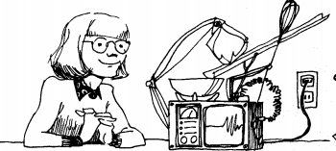  Inspired by Israeli Nobel Prize Winners, use your imagination to think of an invention that would make life better, safer or more fun.  Your invention’s name  __________________________________________________________________________  What does your invention do?  __________________________________________________________________________  __________________________________________________________________________  __________________________________________________________________________  How would this improve life?  __________________________________________________________________________  __________________________________________________________________________  __________________________________________________________________________  _________________________________________________________________________ | Nobel Prize Invention Activity  Inspired by Israeli Nobel Prize Winners, use your imagination to think of an invention that would make life better, safer or more fun.  Your invention’s name  __________________________________________________________________________  What does your invention do?  __________________________________________________________________________  __________________________________________________________________________  __________________________________________________________________________  How would this improve life?  __________________________________________________________________________  __________________________________________________________________________  __________________________________________________________________________  __________________________________________________________________________

