January 31st, 2014
The Face of Israel
Ancient land - modern stories

For this Super Bowl weekend -
American Football in Israel
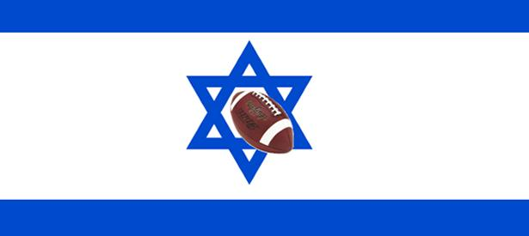The Israel Football League was founded in the summer of 2005 by a group of Israelis, led by Ofri Becker, who wanted to play tackle American football. The first season, played without pads or an official governing body, began in the Fall of 2005. In 2007, the league began fully equipped play under the umbrella of American Football in Israel (AFI). The IFL is sponsored by New England Patriots owner Robert Kraft and his family.
Kosher football – the games never take place during Saturday and are only held on Thursday and Friday mornings and afternoons.
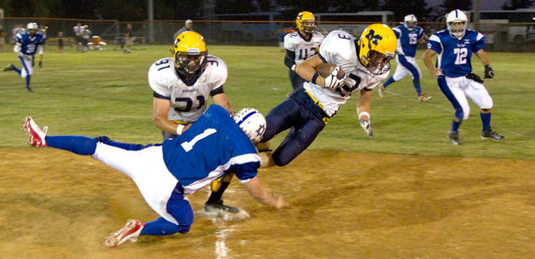From the website of the Israeli Football League:
It has now been six years since the dream of tackle football in Israel really took hold. What began as a group of 25 enthusiastic and energetic Israel-born athletes playing without pads in the Tel Aviv “Sportek” park has grown exponentially into a thriving community of more than 600 players country-wide, with the demand for and interest in our sport growing stronger every day.
Our parent non-profit body, American Football in Israel, is the government-recognized federation for our sport in the country. As well, our unique partnership with the Kraft family, owners of the NFL’s New England Patriots, has allowed us to cultivate a strong relationship with one of the greatest football organizations in the world. This bond will prove invaluable as we continue to spread the fundamentals of football and teach the principles of sportsmanship, team unity and competition to new and old fans and players of the game.
From four initial teams, to five the next year to eleven this last season, the Israeli Football League (IFL) has steadily and consistently grown with a big-picture eye on the future. This fall, the league will continue to mature and showcase the expansion of this great and exciting game to the Israeli market.
Creating pockets of football throughout the country at both the youth and adult levels will allow us to extend our reach and exposure through grassroots initiatives and higher media coverage. It is our dream that within the next 10 years, football will join soccer and basketball as a top-tier sport in Israel, to the extent that every child will consider it a viable option to play from a young age.
It is the unique ability of football to inspire and encourage people to higher levels of personal and professional achievement, growth, maturity, and respect for each other that makes it so rewarding to be involved with in any capacity. The past three seasons have produced innumerable memorable moments. With all of our help, the future will no doubt produce even more enthralling memories as the IFL continues to unite people across this great nation.
From a potential dream career in American sport to the Israeli military
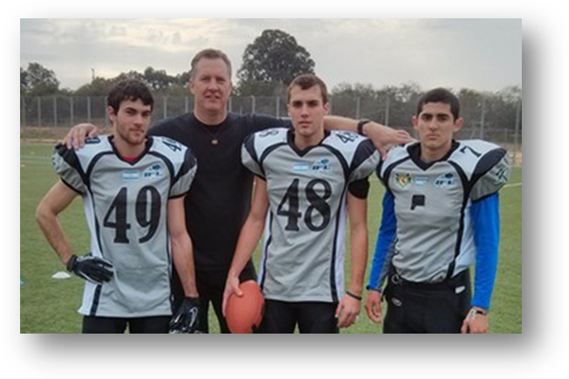Yonathan (in the middle) is the son of an American dad and an Israeli mom. He used to play high school basketball and football in the U.S. In 2007 he won, with his team the national championship - and also got the MVP! He could have gone to any college he wanted, but eventually decided on a very special college called – “The IDF” and became a combat-solider after doing Aliyah. Today he lives in Israel, and together with his two brothers, Jordan and Thomas, he plays in the Israeli Football League.

Watch the Israeli American Football League on YouTube.

Shabat Shalom,
Yoni Alon, Robert E. Loup JCC Israeli Shaliach

