הסבר כללי: יש כאן תמונות של אנשים עם דיעות שונות בנושא. מדפיסים ותולים את כל התמונות על הקיר של החדר, ומבקשים מכל משתתף לרשום תגובה לשלושה מיתוך העשרה שישנם.
ניתן לעמת את המשתתפים בדיעות השונות שנוצרות בחדר, במה הם מסכימים ובמה חולקים. זו מתודה ממש טובה, וניתן להתאים אותה בצורה שמתאימה לכם.

Immigrant workers and refugees - an Israeli dilemma
Targets:
The chanichim will learn to acknowledge the complexities of the Israeli realities, by focusing on a specific issue: attitudes toward immigrants immigrant workers and refugees.

Program outline:
- Introduction (5 min)
Watching this short clip: http://www.youtube.com/watch?v=ijOdup6rvWE
The councilor will summarize the clip by asking question :
- Who are the key players here:
- The African:, that we can devide into 2 main groups – war refugees and people seeking work and a better life.
- The government: it has no official policy regarding the Africans so they are giving them only short term permits.
- NGO’s: trying to help the Africans
- Residents of south Tel Aviv: we didn’t meet them yet, but soon.
- Why are they coming to Israel? For years the border with Egypt did not have a good fence so it was relatively easy to cross. This is easier than getting to EUROPE, since there is no sea to cross. Only recently Israel finished the fence but estimates are that there are that there are around 242,000 immigrants, some of them with legal papers but most without.
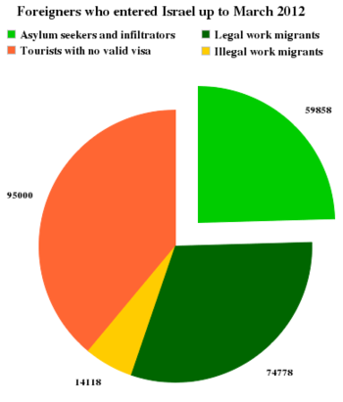
The councilor will present the question: what do you think that the Israeli government should do? Let the immigrants stay in Tel Aviv, or return them to their home countries.
- Meeting city residents
Now, let’s meet the people of Tel Aviv! The councilor will show the chanichim figures of the different city residents, each holding an opinion regarding the question. The pictures will be hanged on the classroom walls. The chanichim will be asked to go around, reading about each figure, and the opinion it holds. The residents are:
- The mayor: "The Africans changed the demographic balance in the city. In south Tel Aviv the frequency of poverty and increased due to their arrival. We are trying to help, like opening schools for them, but this is burdening the municipal systems and our budget"
- Restaurant manager: "I am happy to employ African immigrants. They are willing to work for a low salary, thus enhancing my revenue. They are also doing work that Israelis are not willing to do, like dish washing. At the same time, the image of the city suffers, and image is everything for a touristic city like Tel Aviv".
- The IDF officer: "It is good that we finished the on the Egypt Israel border. This way we can prevent the entrance of African immigrant. We are also able to prevent the entrance of terrorists and criminals among these immigrants.
- A Darfur refugee: "I escaped to Israel, risking my life, and going through a long and difficult road. In my country, I was persecuted, and my life was in constant danger".
- A Sudanese work migrant: "In Sudan, I left a family to which I am sending money regularly. My country suffers from drought, hanger and corruption for years. Many are unemployed, and their families are hungry. All my savings were put into coming to Israel, hoping to support my family with dignity".
- Holocaust survivor: "As a Jewish state, Israel cannot ignore the suffering of other nations. We must allow African immigrants to live here".
- Human rights activist: "Israel signed international treaties that require it to allow refugees a safe haven".
- Interior minister of Israel: “Israel is supposed to be a Jewish state. Non-Jewish immigrants are changing the demographics. Also, It is not good for everyone, including the Africans, to have such a large group without legal status for a long time. “
- South Tel Aviv resident: “the neighborhood had completely changed in the last years. Everyone who lived here left and the Africans took their place. I can’t move because it is expensive to rent elsewhere. No it became a poverty neighborhood that is unsafe”.
Once the students read all of the opinions, the councilor asks the students to stand by a figure they want to ask a question, whose opinion is not completely clear to them.
The councilor will ask students standing by the different figures what were their questions, seeking for answers with the help of all of the other students.
Next, each student will be asked to stand by a figure to which they oppose. The councilor will ask students from the different groups to tell the rest of the class why do they oppose this position.
Last, each student will be asked to stand by a figure to which they agree. The councilor will ask students from the different groups to tell the rest of the class why do they agree with this position.
- Conclusions
The councilor asks:
what did learn from this activity?
What do you think Israel should do?
Do you see Israel differently in any way?

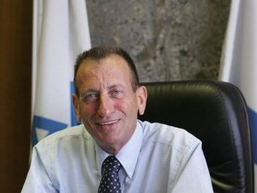
The mayor: "The Africans changed the demographic balance in the city. In south Tel Aviv the frequency of poverty and increased due to their arrival. We are trying to help, like opening schools for them, but this is burdening the municipal systems and our budget"

Restaurant manager: "I am happy to employ African immigrants. They are willing to work for a low salary, thus enhancing my revenue. They are also doing work that Israelis are not willing to do, like dish washing. At the same time, the image of the city suffers, and image is everything for a touristic city like Tel Aviv".

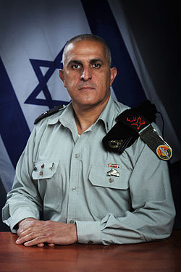
The IDF officer: "It is good that we finished the on the Egypt Israel border. This way we can prevent the entrance of African immigrant. We are also able to prevent the entrance of terrorists and criminals among these immigrants.

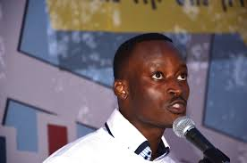

A Darfur refugee: "I escaped to Israel, risking my life, and going through a long and difficult road. In my country, I was persecuted, and my life was in constant danger".

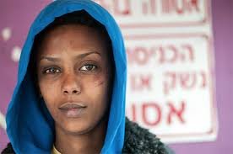
A Sudanese work migrant: "In Sudan, I left a family to which I am sending money regularly. My country suffers from drought, hanger and corruption for years. Many are unemployed, and their families are hungry. All my savings were put into coming to Israel, hoping to support my family with dignity".

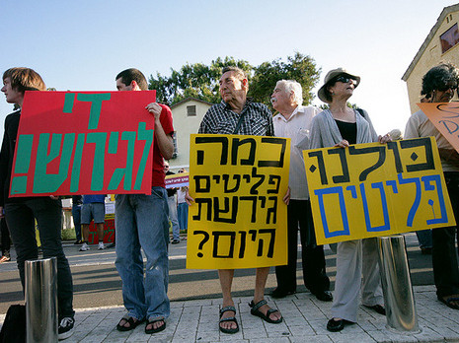
Human rights activist: "Israel signed international treaties that require it to allow refugees a safe haven".

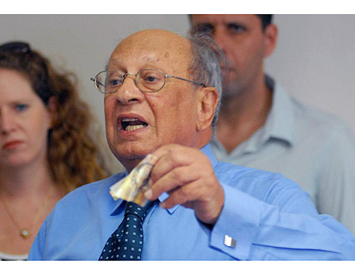
Holocaust survivor: "As a Jewish state, Israel cannot ignore the suffering of other nations. We must allow African immigrants to live here".

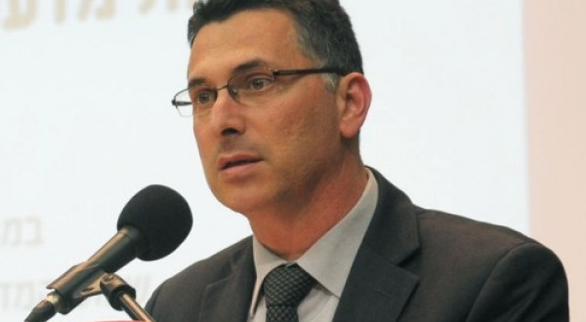
Interior minister of Israel: “Israel is supposed to be a Jewish state. Non-Jewish immigrants are changing the demographics. Also, It is not good for everyone, including the Africans, to have such a large group without legal status for a long time. “

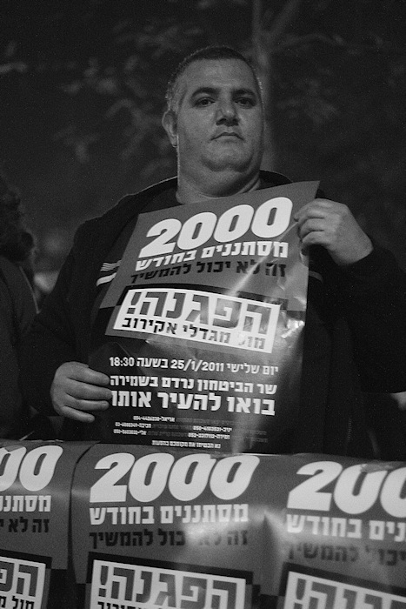
South Tel Aviv resident: “the neighborhood had completely changed in the last years. Everyone who lived here left and the Africans took their place. I can’t move because it is expensive to rent elsewhere. No it became a poverty neighborhood that is unsafe”.

