Falafel
פלאפל
Falafel is a deep-fried ball or patty made from ground chickpeas, fava beans, or both. Falafel is a traditional Middle Eastern food, commonly served in a pita, which acts as a pocket, or wrapped in a flatbread known as lafa. The falafel balls are topped with salads, pickled vegetables, hot sauce, and drizzled with tahini-based sauces. Falafel balls may also be eaten alone as a snack or served as part of a meze (appetizers).
Falafel is a common dish eaten throughout the Middle East. The fritters are now found around the world as a replacement for meat and as a form of street food.
The origin of falafel is unknown and controversial. A common theory is that the dish originated in Egypt, possibly eaten by Copts as a replacement for meat during Lent. It is very popular in Israel.
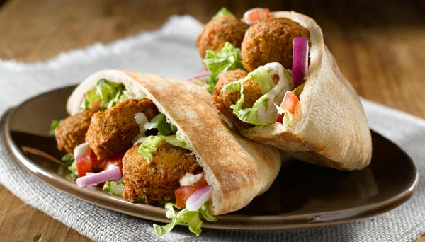

Shakshouka
שקשוקה
Shakshouka (שקשוקה); is a dish of eggs poached in a sauce of tomatoes, chili peppers, and onions, often spiced with cumin. It is believed to have a Tunisian origin. Well known in the Israeli kitchen.
Shakshouka means "a mixture" in Tunisian Arabic or other maghrebi dialects. It is likely that it was first known as chakchouka, a Berber word meaning a vegetable ragout, although "shakshek" means "to shake", in Tunisian Arabic, Berber and Hebrew, giving a possible punic origin to the name of the dish.
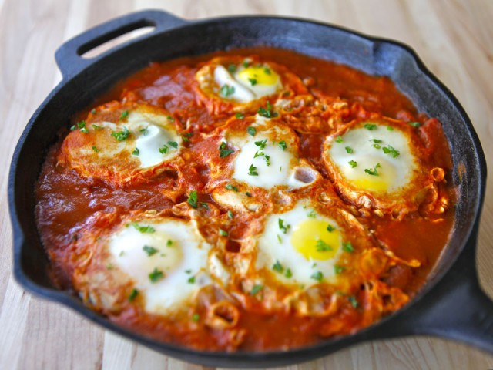
Chakchouk is also a very common surname in Tunisia.

