Hagshamantion in Israel
Social Projects

For us, the informal educators, Zionism on the 21th century equals education.
In the last 40 years hundreds of social organizations were established in Israel. Those organizations and projects were established in order to deal with social needs and as an answer to main problems that the Israeli society suffers from. Such as racism, poverty, political polarization, educational gaps and etc.
We believe that there’s always a hope. We strive to shape and create a just society, a generation that is not afraid to think and see things differently, a better world for all of us.
We wanted to present you a couple of projects and organizations in Israel that represent our vision.
Hope you’ll enjoy it,
HDNA Mishlachat 2014-2015

Bina Secular Yeshiva

BINA is the leading organization at the intersection of Jewish Pluralism & Social Action in Israel. BINA strives to strengthen Israel as a democratic pluralistic society, by emphasizing Judaism as a culture, through Jewish values of Tikkun Olam (in Hebrew means "repair the world"). BINA means "wisdom" in Hebrew and it is also an acronym in Hebrew for “a workshop for the soul of the nation”: A phrase coined by Hebrew poet Chaim Nachman Bialik.
BINA designs and implements year-long programming, integrating cultural, social and educational elements of Judaism that reaches nearly 1,000 secular Israelis annually. BINA also offers seminars and public events for more than 25,000 participants every year, with the goal of enhancing the cultural identity and communal involvement of Israelis. BINA’s service and learning programs aim to inspire life-long appreciation and engagement in personal learning and social justice.

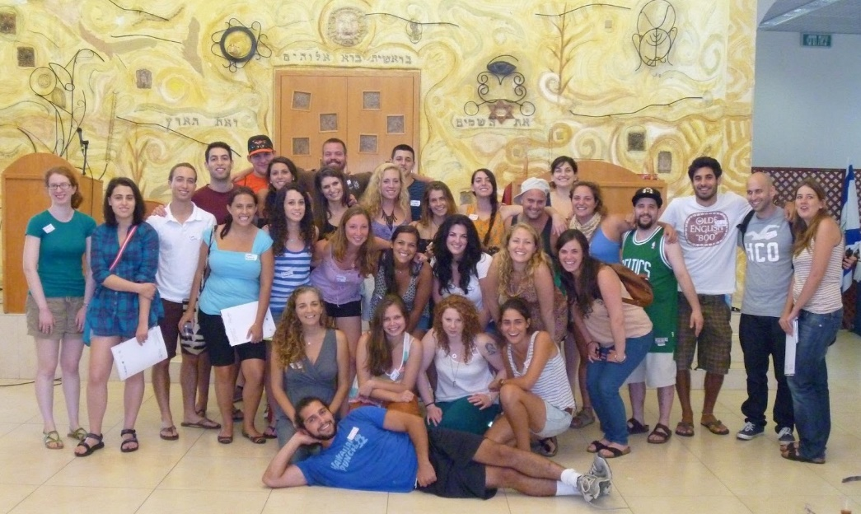

Eretz Shalom

Eretz Shalom is a social movement which works toward the advancement of peace and dialogue between the Jewish and Arab inhabitants of Judea and Samaria. The movement is mostly made up of sons of Abraham, Jews and Arabs who are interested in living in their homeland in mutual respect and cooperation with their neighbors. We understand that we are destined to be neighbors for many more years, it is in our interests and is, indeed, our mutual desire to advance good neighborly relations. Eretz Shalom is not a political movement and does not presume to offer conclusive solutions or to formulate peace agreements, but rather works from the participate in dialogue and joint projects in education, religion, culture and the environment in the hopes of creating change that will burgeon from the bottom up.

“It is obvious to all how the concept of ownership in regard to the land leads to many of the conflicts and even wars. Concepts of ownership and possessions in regard to the land are not only dangerous but also very far from what Judaism teaches, an example of this would be the laws of the sabbatical year where the land stays barren and ‘returns’ to it’s creator. We follow the scripture’s statement that “to myself is all the land”, meaning that only G-d owns the land and all humans are just temporary inhabitants. If in the first generation of the settlement movement the motto was “The land of Israel belong to the people of Israel”, we who follow the teachings of Rabbi Froman claim that “The people of Israel belong to the Land of Israel”, meaning we belong here and we love the land that we live on. This approach of belonging is a much more modest and less forceful approach towards the land. This seemingly semantic change can alter the type of dialogue and the language used in it.”
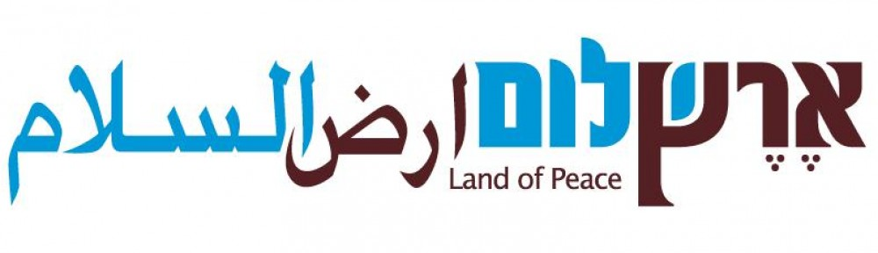

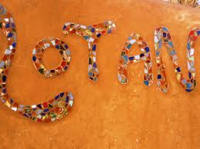
Kibbutz Lotan

Lays amidst the beauty of the sun drenched Arava Valley in southern Israel and is home to stunning desert birds such as the Little Green Bee-Eater and the Hooded Wheatear. In the heart of it all, Kibbutz Lotan has become recognized as an oasis in the dry desert and renowned for eco-tourism services and sustainability.

Founded in 1983 by Reform youth movement graduates, Kibbutz Lotan is one of the youngest Kibbutzim in Israel. Its population is small, consisting of many families, members, volunteers, students and tourists. Almost all share an interest in nature and enjoy dwelling in the beauty of their desert home. At any given time, there are approximately 150 people that live at Kibbutz Lotan.

Lotan’s population is equally divided between native-born Israelis and immigrants from all over the world. Hebrew is the commonly used language but English is also spoken. Our economy is based on date plantations, dairy, tourism, holistic health center, mariculture and various professions held by members who work outside of the kibbutz. Presently we number 150 people at the Kibbutz daily.

Kibbutz Lotan is a member of the European branch of the Global EcoVillage Network and in 2006 was awarded for EcoVillage Excellence in recognition of its work in promoting natural building, waste management, and environmental education and also for promoting sustainability through the building of bridges between different ethnic groups throughout Israel.
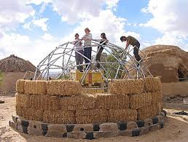
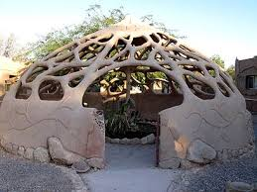

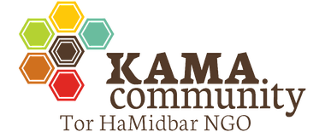

Cafe Ringelblum
Café Ringelblum serves gourmet pasta and fish meals, as well as coffee, pastries and breakfast to neighborhood regulars and visitors - while also serving an important social mission.
Apart from a lovely culinary experience, the café provides employment for 10 at-risk youth each year, offering them a holistic occupational-social program, in which each youth receives a plan tailored to him or her. The program supplies the youths with a significant educational framework, while allowing them to make an honest living and to acquire a profession. In addition, Tor Hamidbar runs a program for the 55 alumni of Café Ringelblum youth program, and guides them during their army service, new jobs, and even through college.
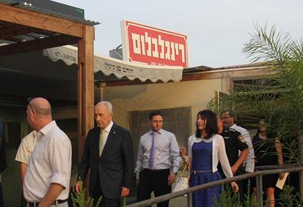

Dror Israel Movement
The Educators' Kibbutzim of the Dror Israel Movement are part of a multi-generation social movement established by the graduates of the HaNoar HaOved VeHaLomed Youth Movement. The members of the Kibbutzim aspire to realize the values of the youth movement they grew up on throughout their adult life.
The Dror Israel movement is a pioneer Zionist movement of educators that work in all sectors of society to strengthen faith in man and action in society and to actualize the values of equality, social alliance and social responsibility in everyday reality.
The movement members' way of life places the equality of the value of all people and the happiness of all people in the center. The members of the movement live in communal groups that help each individual shape his or her life in an active way.
The movement is composed of alliances of individuals and communal groups aiming to advance Israeli society through general education and friendly interpersonal communication.
The members of the movement act out of a sense of mission to realize the vision of the founders and fathers of the Zionist movement: Theodore Herzl, Berl Catzenelson, the members of the pioneer Zionist movements in the Holocaust and others.

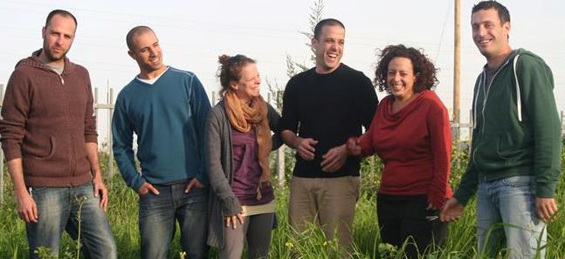

Urban Kibbutz
An urban kibbutz (Hebrew: קיבוץ עירוני‎, Kibbutz Ironi) is a form of kibbutz located within an existing city. There are currently just over 100 in Israel, totalling around 2,000 members.
Although there were attempts to form urban kibbutzim in the early 20th century, their success was limited and most failed. The idea was revived in the 1970s when they were established as co-operative communities by former kibbutz members and Nahal graduates. They were created as a way of retaining the kibbutz lifestyle whilst moving into mainstream society, but more recently have been seen as a way of combatting social problems; in Haifa the city council asked members of the HaNoar HaOved VeHaLomedyouth group to form an urban kibbutz in the Hadar neighbourhood in order to work with at-risk children.
Some standard kibbutzim such as Mesilot began as urban kibbutzim. The urban kibbutz in Gedera was the first Ethiopian kibbutz in the country.

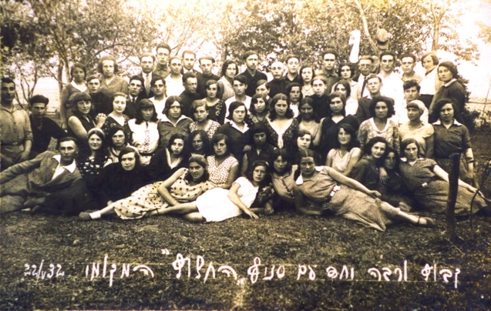

Heartbeat

Mission: Heartbeat unites Israeli and Palestinian youth musicians to build critical understanding, develop creative nonviolent tools for social change, and amplify their voices to influence the world around them.
As a positive alternative to the normalization of segregation, violence, and racism, Heartbeat creates spaces and opportunities for Palestinian and Israeli youth musicians to build critical awareness, respect, and trust while harnessing creative nonviolent tools for self-expression and social change. Engaging in a sustained music, dialogue, and empowerment process, Heartbeat youth musicians become agents of change; harnessing the tools of creativity to imagine possibilities, ask questions, and publicly address systemic problems such as violence, oppression, and inequality — partnering to create a safe, equitable future for all.

WHY Heartbeat?
Heartbeat breaks through entrenched physical and psychological barriers as a constructive alternative to the status quo of segregation, violence, racism, and the power differentials brought on by years of conflict, occupation, and war.
Years of traumatic violence, increasing segregation, antagonistic educational and media policies, and occupation have dramatically polarized the Israeli and Palestinian populations. Tensions between Israeli Jews and Palestinians are on the rise as continued fear, distrust, and increased separation further distance these communities from each other, thereby prolonging the status quo. While the few who use violence and racism dominate headlines and dictate how our communities interact, the vast, silent majority of Israelis and Palestinians yearns for a secure, equitable future but is largely unheard and so remains unaware of its power to influence others and transform the status quo.
In the past 20 years, less than 1% of the Israeli and Palestinian population has come together for a meaningful, sustained respect and trust building experience. Even within Israel, most Arabs and Jews live in separate neighborhoods and attend separate schools. To transform this protracted struggle for land and recognition, we urgently need to provide safe, engaging spaces for youth from both sides to build critical awareness of their reality, to come to trust and respect each other as equals and to imagine and proactively co-create locations of possibility.
By enabling more efforts to amplify and multiply such experiences, we will build awareness, respect and trust across a critical mass of 25% of the population; thereby making respect and trust unstoppable.
