Culture Web Package
Israeli Culture 101
What is Israeli culture exactly?
Well, when discussing the distinctiveness of Israeli culture there are a number of important things to remember – Israel is a country comprised of mostly immigrants and with that said the very fundamentals of Israeli culture are a mix of its immigrants and the vision of the Zionist movement for a “New Jew”.
Israel is defined by many different factors that create a diverse character to the culture. This can be seen in the language, the food, the music, the art, the architecture etc. In this web package will be different tips of things you can do, show and point out on Tour to your chanichim. There are some main aspects that define Israeli culture and we will go through them – try to read and understand little things that might have escaped you on previous visits to Israel:
The aspects:
Judaism: Obviously the Jewish State that was conceived by the early Zionists would have to have a Jewish character. The Language spoken across the Jewish world varied (Yiddish, Ladino, French, German, English and so on) and their practice of Judaism changed practically from village to village; however the common denominator to all these people was their prayer to Jerusalem and their shared history. This is why Eretz Yisrael was the eventual and obvious choice for a Jewish homeland and Hebrew (Ivrit) chosen as the language. One of the main challenges of the first Zionists was to create a culture that would accommodate and sustain everyone, especially in a land that was mostly barren and new. One of the first things that people did upon arriving in Israel (and mostly before arrival) was learn Hebrew in an Ulpan and many times change their names. A lot of Zionist leaders had changed their names in order to change their identity from the “Old European Jew” into the “New Israeli Jew” and the same had been done throughout the aliyot:
Name | Original | Known for | Meaning
David Ben Gurion | David Green | First Prime Minister | Yosef Ben-Gurion was a leader in the great uprising against the Romans and one of first resettlers of Jerusalem in his time.
Ahed Ha’am | Asher Tzvi Ginzberg | Zionist Thinker | Literally: One of the People
Ze’ev Jabotinsky | Vladimir Yevgenyevich Zhabotinsky | Zionist Thinker and founder of the Jewish Legion in the British Army | Translates to “Wolf” – the symbol of the tribe of Benjamin
Eliezer Ben Yehuda | Eliezer Yitzhak Perlman | Reviver of the Hebrew language, Father of modern Ivrit | Translates to “Son of Yehuda”

To this day many Israeli have similar surnames or surnames like “Banai” and “Magal” which mean “Builder” and “Sickle” respectively. These were names that people took upon themselves to become part of the new emerging society. This is not distinctive only to Israel – it is true of any immigrant in any country. Bring up this subject to your tour and see how many people know the history of their surname and how it changed throughout the ages in the UK and beyond.
Judaism permeates throughout every aspect of Israeli life whether it goes more noticed or unnoticed it is etched into the cultural DNA of Israel.
– Here are some things you can point out to your chanichim for instance in Jerusalem:
The Israeli Parliament is called the “Knesset” because of “Haknesset Hagdola” (The great assembly): also known as the Great Synagogue, was, according to Jewish tradition, an assembly of 120 scribes, sages, and prophets, in the period from the end of the Biblical prophets. This is also the reason the Israeli parliament has 120 seats!
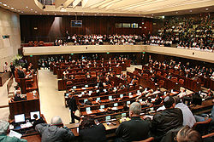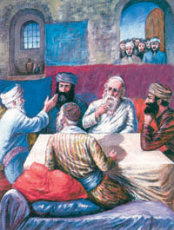
The Menorah with two olive branches is the symbol of the State of Israel
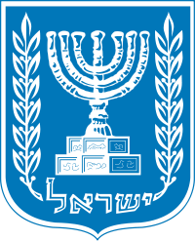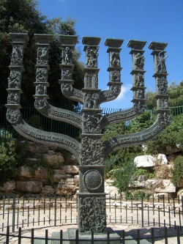
Many streets in Israel are named after Biblical figures, interpreters of the Torah and modern figures as well. Many times signs will have a brief summary of who the street is named for and why.
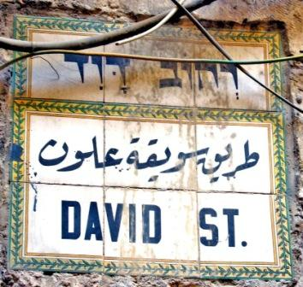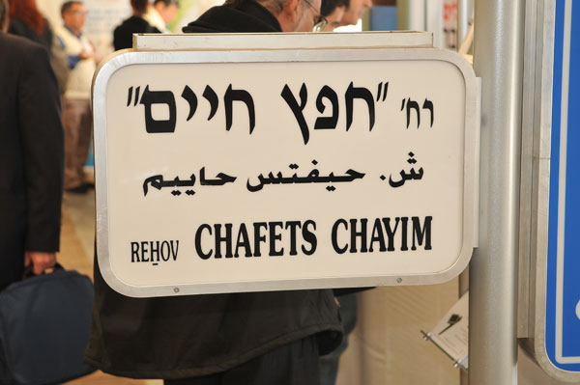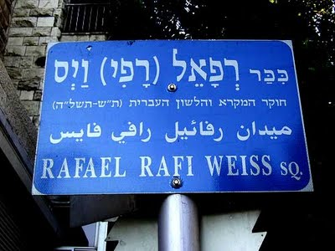

In Jerusalem, by law, buildings are built with “Jerusalemite Stone” – all the buildings must have a facade of stone in order to keep the city with a distinctive architectural character of the ancient city.
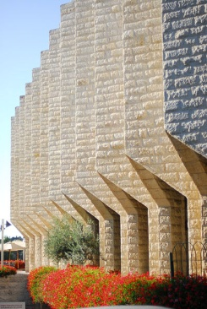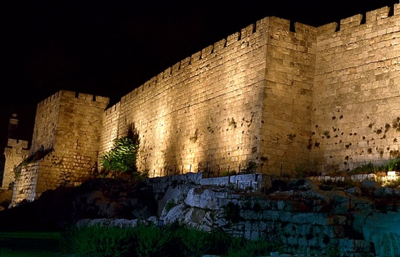

When in any city you can use http://print-bingo.com/ which is an awesome website that generates bingo cards – Just fill in the blanks with things they might see in the city (Western wall, King David Street, the Knesset etc.) and this will get them to look up out of the windows and also remember the names of places and things that they see! * If you want to go a step further print out pictures of these places so they could see them and recognise them from memory as well!
European Jewry: European Jewry was the majority of the first waves of Aliyot. Most of them came from Romania, Germany, Poland and so on. A lot of these waves brought with them a European culture that set the tone for years to come. One of the greatest examples to point this out would be in Tel Aviv.
Tel Aviv has a distinctive “Europeaness” to it. For Instance the Architecture
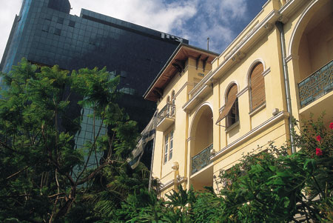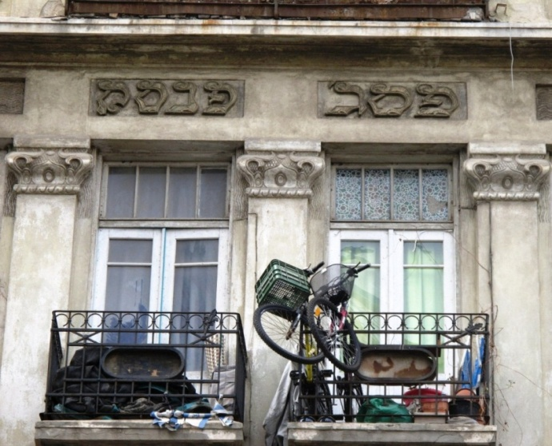
One of the great things to point out in Tel Aviv are the first signs of Modern Jewish architecture – Notice the Hebrew writing on the building above and the menorah on the balcony below.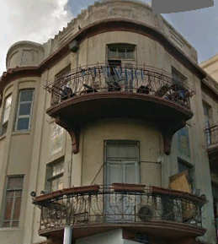

“Habima” is the National theatre of Israel – with that, its name comes from the term for the stage in the centre of a synagogue the “Bima”. Yet another example of how Judaism sets the tone for a lot of the culture in Israel.
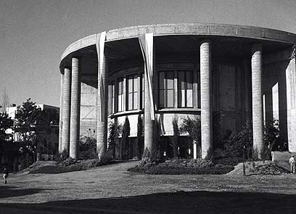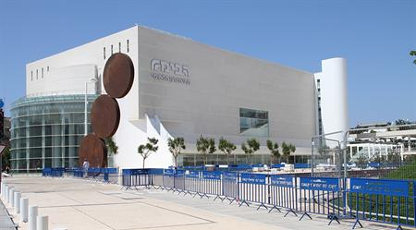
Habima – past and present (above).
The culture that the Europeans brought with them was not only in the theatre, cafes and architecture that are felt strongly in Tel Aviv to this day – along with Herzl’s vision of Israel being a Socialist country, the kibbutzim were predominantly Ashkenazi and many European Zionists created the first Kibbutzim.
Another really cool thing about Tel Aviv is that the streets are also placed in a way that they have meanings: for instance Weizmann street and Jabotinsky street cross each other at Kikar Hamedina (The National Roundabout) – Weizmann and Jabotinsky were the heads of two conflicting schools of thought – Weizmann, a Spiritual Zionist and Jabotinsky a Revisionist – therefore it is fitting that they cross at the National Roundabout.
Many of the first Zionists were Marxists. The ideal of being socialist came from an understanding that the state must be built together, and by building a state, a people with a shared cultural identity will be built from within it. The sentence:
אנו באנו ארצה לבנות ולהבנות “Ano banu artza, livnot ve’lehibanot”
Translates to: “We came to Israel, to build and be built. “
And it is an example of the mottos that characterised the time.
A great game to show the ideals of the era or when visiting a kibbutz would be:
Get a long rope and tie the edges together – make sure this is an actual rope and not string! – get the whole group to hold on to the rope and lean back a bit. Now the whole group must sit and then stand (as the madrich will instruct) and use the rope to help them. After this if there is time, a volunteer can try to walk and make his/her way around the circle while the whole group helps hold him/her up. This can be used to symbolise the way in which everyone at the time shared the burden and worked together to get tasks done – and to this day in some kibbutzim they still work communally.
Jews from Arab countries:
The influence of Jews from Arab countries is felt very strongly to this day. Jews from Arab countries had begun arriving with the first wave of Aliyah from places like Yemen and North Africa however they were not a strong influence on the culture itself until later years. Many of the Jews from Arab countries had arrived after the establishment of the State of Israel. The Arab-Jewish culture was not introduced into the mainstream and was not a strong influence on culture however slowly through the 70’s and 80’s Food and Music had become much more popular and the results are most apparent today: with food like the ever-popular Falafel, the much beloved Sabich and the most celestial Schwarma – all of which are of course accompanied by Hummus and Tehina.
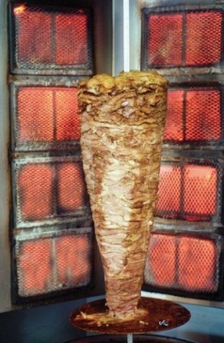
These foods are so incorporated into Israeli society that most Israeli’s would not be able to tell you which originate where. See if you’re chanichim can match the country of origin with the food:
Falafel - Egypt
Schwarma - Turkey
Sabich - Iraq
Shakshuka - Morocco
Kuskus - Lybia
Chummus – Controversial – Egypt, Jordan, Lebanon (Depends who’s asking)
Kobe - Iraq
Schug (Harif) – Yemen (Harif means Hot/spicy)
Bamba and Bisli – ISRAEL!!
Another major influence aforementioned is the Mizrahi Music which is popular in the Israeli nightlife and radio. Mizrahi music had very humble beginnings as tapes sold on the street corners - famous artists like Zohar Argov known as “Hamelech” (The King) were rarely played on mainstream radio. Argov was a major influence on big singers like Eyal Golan.
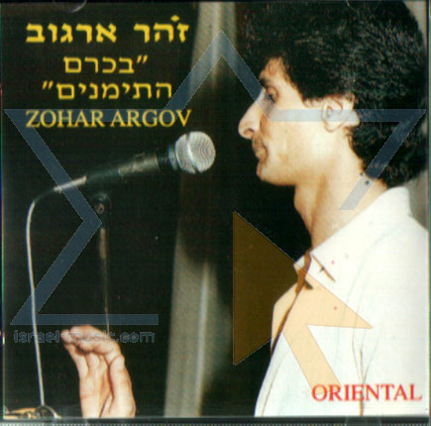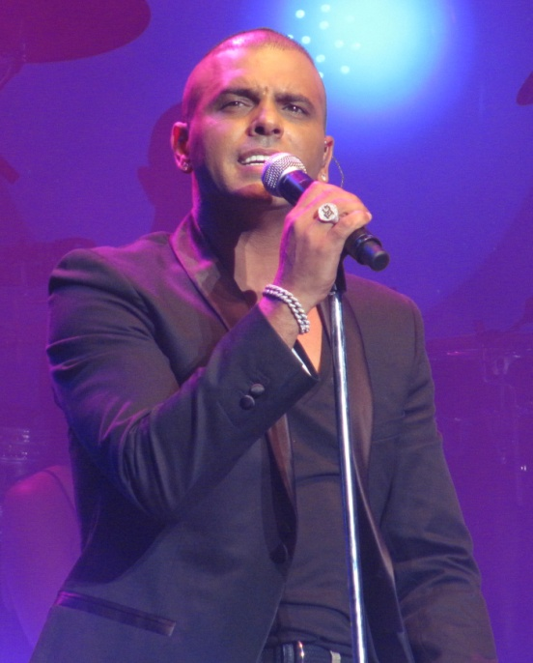
Today Mizrahi music is not only in the mainstream but you can hear its influences in big bands in Israel and abroad like Hadag Nahash and Balkan Beat Box.
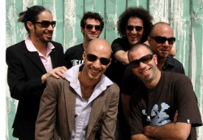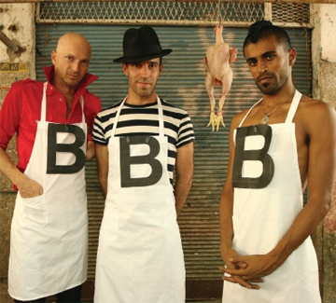

A great thing you can do on coach journeys is to play Israeli Music on the coach – some bands that incorporate many aspects of Israeli society and also represent different cultures in it:
Hadag Nahash – Shir Nehama (Mizrahi Influnece with some funk)
http://www.youtube.com/watch?v=d1uvv83Z_FY
Balkan Beat Box – Adir Adirim (Arabic, Hebrew prayer and boozoki guitar)
http://www.youtube.com/watch?v=4XxuIKBhpfM
Idan Raichel – Mema’amkim (Ethiopian singing)
http://www.youtube.com/watch?v=kmW2yAYhMmM
Hagroovatron – Pitom Kam Adam (Funked up version of old Israeli songs – In the lyrics is the Israeli Declaration of Independence)
http://www.youtube.com/watch?v=Wu0dAgK-smI
AND LAST BUT NOT LEAST – A video by artist Kutiman – taken from all across Jerusalem mixing different artists with different backgrounds to make a wonderful harmony that represents the city.
http://www.youtube.com/watch?v=mHglfyQOd2s
The Army
The army is one of the most influential things in Israeli society. From the inception of the state to this day the army is the heart of the consensus in Israeli society and in many ways has influenced and does influence the culture. The IDF is in many ways “The Melting Pot” in which all layers of Israeli society meet each other and work together. One of the famous mottos:
“Am bone tzava bone am” "עם בונה צבא בונה עם"
Translates to “ A people build an army builds a people”.
For all these reasons and more the army is a defining character in modern Israel. Any Israeli that has been in the army can tell you within a number of seconds almost everything about a soldier just by looking at the uniform- Your chanichim may notice that different soldiers have different colour berets – this symbolises the units the soldiers are in – try to see if they can tell who’s who by the colour:
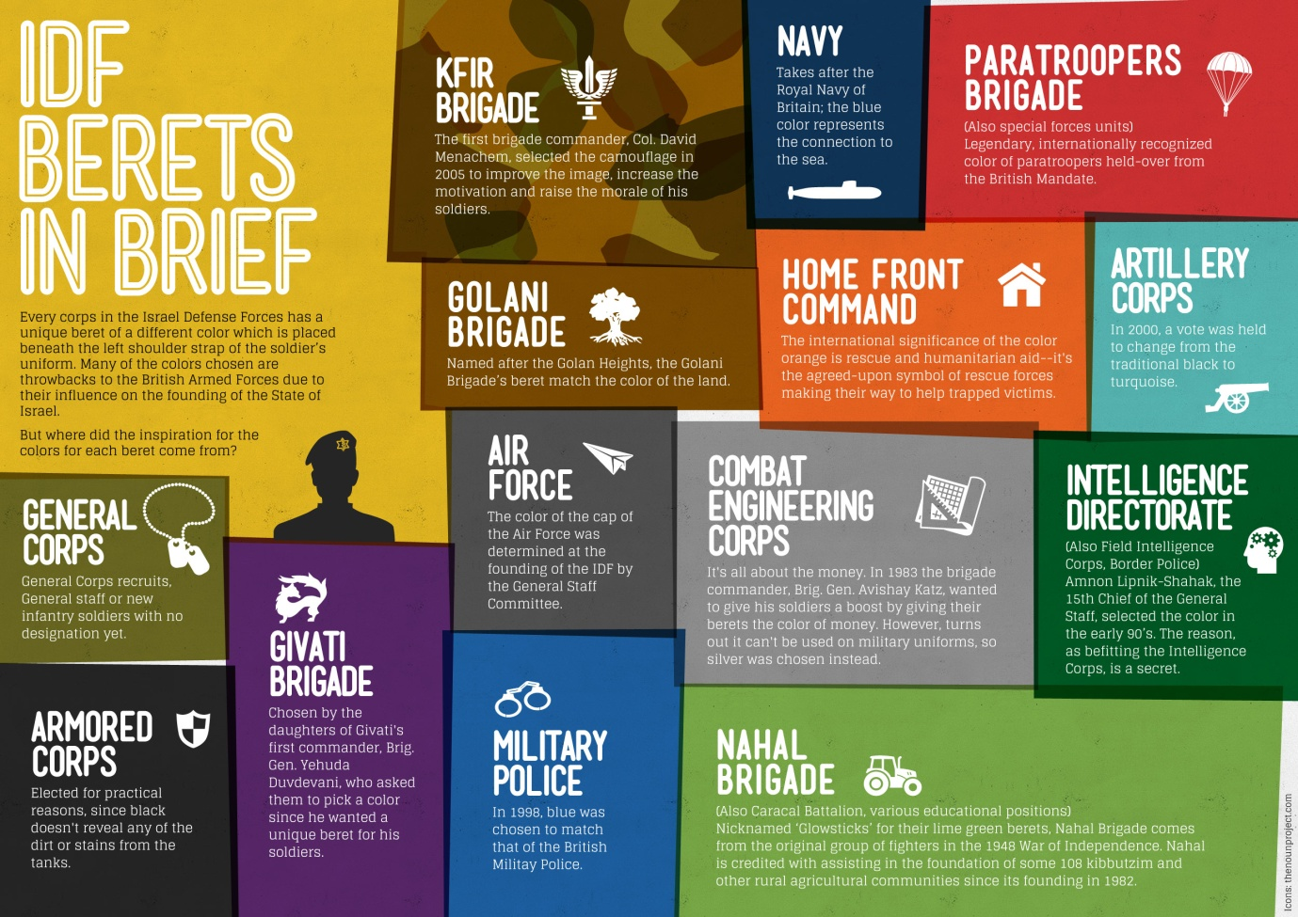

In the early years of the state, the main radio station and most of the bands were those of the army and to this day one of the main radio stations is GALATZ which is short for GALAI TZAHAL or “Tzahal (IDF) Radio”. Some of today’s biggest Israeli singers began their way in the IDF Bands:
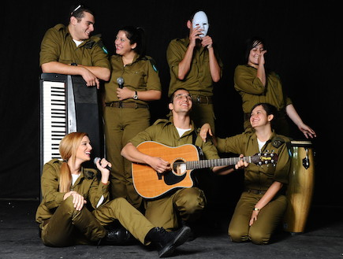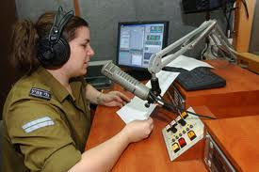

The Navy Singing Band and Shlomo Artzi, who began his career there, today
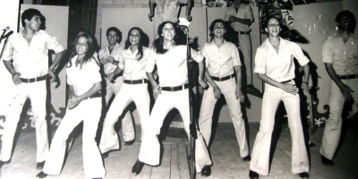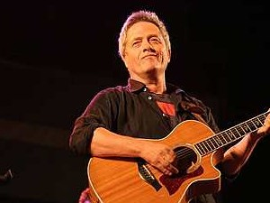
The IDF is also a major factor in the Israeli Slang and way of speech. In the army words are shortened to acronyms. See if your chanichim can guess what some of these acronyms and slang actually mean (you can make these questions into a multiple choice):
ACRONYM | SPELT OUT | TRANSLATION | ACTUAL MEANING
CHAVLAZ | CHAVAL AL HAZMAN | ITS A WASTE OF YOUR TIME | AWESOME
SCHLEH | SOLER, CHOL, LICHLUCH, AVAK | DIESEL, SAND, DIRT, DUST | GROSS THINGS (Usually the things that come out of tanks)
PAZAM | PEREK ZMAN | AMOUNT OF TIME | EXPERIENCE IN ANYTHING (Usually in the army
SHNATZ | SHANT TZAHARIYIM | SLEEP OF THE NOON | AFTERNOON NAP
BALTAM | BILTI METUCHNAN | UNPLANABLE | SOMETHING UNEXPECTED
HAMSHUSH | HAMISHI SHISHI | THURSDAY FRIDAY | AN EARLY WEEKEND BREAK
TASH | TNA’EI SHERUT | TERMS OF SERVICE | QUALITY OF LIFE
HAPSHAN | HAYAL PASHUT | SIMPLE SOLDIER | SOMEONE THAT DOES NOT DO THINGS PROPERLY

One of the most important brigades in the IDF is the NAHAL (an acronym of course – Noar Chalutzi Lochem – Pioneer Fighting Youth). The Nahal were brigades made up from Bogrim of youth movements that wanted to and help the country out as well as do their duty – so the Nachal was assigned to build kibbutzim whilst serving as an infantry brigade.
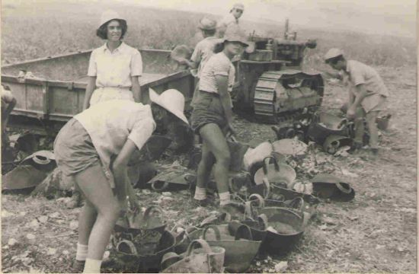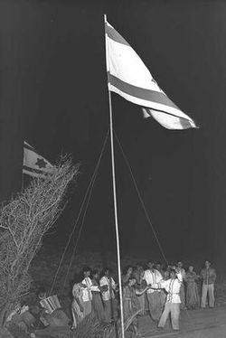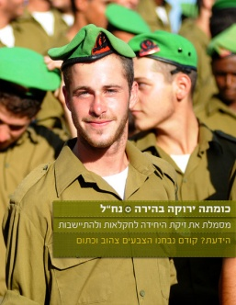
Which leads us to:
The Youth Movements:
The Youth Movements in Israel did not only play an important part in the creation of the state but also are an important component of adolescent life in Israel. 1 in every 4 kids in Israel is part of a youth movement and in Tel Aviv over 50% alone are in the Israeli Tzofim (Scouts). Youth Movements play a major role in volunteer work, community activities and preparation for the army.
This would be great to educate chanichim about their sister movements/movement in Israel.
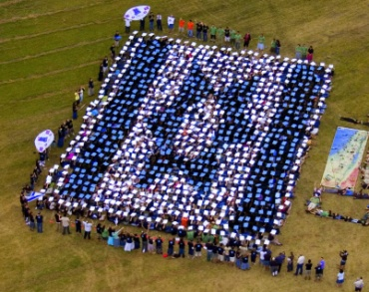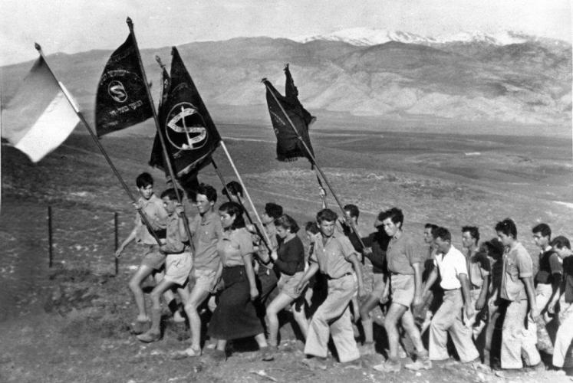

Israeli Culture and Social Issues

Throughout the past, different issues in Israeli society have been dealt with through the arts. Many contentious issues that existed in the society were challenged and still are challenged through the contemporary culture. This can be seen in films, literature, art and other medias – all of which deal with issues like inequality, racism, wars and social taboos. Israeli artists/creators deal with these issues in the arts and bring them up to discussion.
Here are some examples that you can choose to share with your chanichim:
Literature: “Beaufort” - Ron Leshem
The book Beaufort is about an IDF unit located at the Beaufort Castle (Lebanon) post in Southern Lebanon during the South Lebanon war (1982-2000). It takes the form of a narrative written by the unit's commander, Liraz Librati, who was the last commander of the Beaufort castle before the Israeli withdrawal in 2000.

- What we can learn about the life of the character?
- What period of time do you think this book was written and why?
- What can we learn about Israeli society from this book?
Poetry: “Al Kol Eleh” - Naomi Shemer
https://www.youtube.com/watch?v=FkLd_aCjbjY
(Lyrics in English on the Bottom)
This song is about the eviction of the settlement of Yamit in Sinai after the peace agreement with Egypt – it was written in protest.
& “Jerusalem of Iron” – Meir Ariel
https://www.youtube.com/watch?v=Ar7l7Ja-3j0
This song/poem was released in 1967 It is to the tune of “Jerusalem of Gold” by Naomi Shemer. It was released just months after the six day war. Israel was euphoric at the time and Ariel was not sure how he felt about the over-patriotism that was exhibited at this period. This poem called attention to the heavy price Israel paid for its achievement.

- What can we learn about the Israeli society from These songs/poems?
- Do you think it is still relevant in today’s context?
- How does Meir Ariel’s song/poem compare to Naomi Shemer’s?
- What can we learn about the way these artists see Israel?

Theatre: “Malkat Ha’ambatya” – Hanoch Levine
Malkat Hambtya is a play that was written by Hanoch Levine after the Six Days War as a criticism of the Israeli government. The play showed once and was immediately taken off after its debut.
The play shows a new and different point of view about the Israeli victory in the war, different to what was popular at the time. The Israeli government banned the play and later stopped it from playing at all.
- What can we learn about criticism toward the Israeli government on those days?
- What can we learn about the atmosphere in Israel on those days from that play?

Film: “James' Journey to Jerusalem” - Ra'anan Alexandrowicz
This film's plot focuses on an African teenager named James who hails from the fictional African village Entshongweni. He goes on a pilgrimage, on behalf of his village, towards the Holy Land, Israel, and especially in order to come to Jerusalem. Upon arriving in Israel, James is suspected of being an illegal foreign worker and as a result of which he is arrested. Shimi (Salim Daw), a contractor of foreign workers, releases him on bail to work for him. After James explains to him that he did not travel to Israel to work, Shimi clarifies to him that since he paid for his release, James now owes him. Therefore James is forced to interrupt his journey and begin working for Shimi.
Shimi tries to gain a profit at James' expense and makes him work for other people as well. Shimi's wife sees him as a kind of an amusement. Salah, Shimi's father, soon discovers that James is exceptionally lucky at rolling dice and he decides to exploit this in order to win in backgammon games against his friends. James hopes to pay his debt to Shimi so that he can finally reach Jerusalem, but as time passes he learns how to conduct business with the locals. James starts managing his foreign worker friends, and soon he becomes a cheap labour contractor himself, just like Shimi. James buys himself nice clothes, a mobile phone and a TV. As a result, he forgets about the pilgrimage
- When was this film screened? And why?
- What do we learn from it about the Israeli society?

Israel is a very young country and is constantly developing. The culture is ever changing and adapting to its surroundings. As you can see from the above, the arts have played a major role in the development of the culture and through critique and playing with familiar ideas and ideals, Israeli culture builds and advances upon its cultural foundations. As a culture, Israel plays with past and present social trends to create a society that is open and pliable to the changes of the time.

Some More Ideas:
Feel free to play around with these ideas, take them to wherever you feel they will help you most to get a message across to your chanichim.
- The mascot – Get a teddy bear or some such mascot that can go with you everywhere – dress the mascot and decorate with different things you learn along the way – you can prepare different things that will symbolise what you are learning – (A kibbutz hat, an IDF T-shirt, A kipa etc.)
- (If available) show movies, video clips and play songs on the bus that are distinctive to the places you are going.
- The Chart- Try to see how many different things you can find as a tour and chart them. Or, alternatively you can have a chart that has points for different type of things you might run into – the chart could be for example “Foods and drinks” (Hummus – 1 point, Kobe – 5 points etc.) and chanichim can try to spot as many different places as they can and collect points. Use your imagination, the chart could be of different army units or street names!
- Hero of the day – Think of a long list of Israeli/Zionist heroes that are important for you to talk about (If you run out of ideas, just look at a street sign and you will be inspired!) and every day you can read out some facts about said person – if you happen to see a place named after said person – you win Hero of the Day!
- The Symbol –Since almost everything about Israel is symbolic at the beginning of each day find a symbol (A Magen David, A menorah or a even a ball with a note inside) and give it to a chanich – the task is that throughout the day the Symbol must pass secretly amongst the chanichim. For instance one chanich would put it on the lap of a sleeping chanich, then he would wake and pass it secretly into a bag of an unsuspecting chanich and so on. The chanich that holds the symbol at the end of the day must explain what it is/what it symbolises. This is an opportunity to pass along different things you might want to educate about.
Hopefully you have learned a little and will be able to pass on this knowledge to your chanichim. The difference between understanding and not understanding the culture in Israel is one that can really change a chanich’s perspective on the whole trip. No matter where you are, understanding the local culture betters your understanding of everything that surrounds you. Israel is not a simple place to educate about and hopefully you will do this task wonderfully!

Best of luck!

