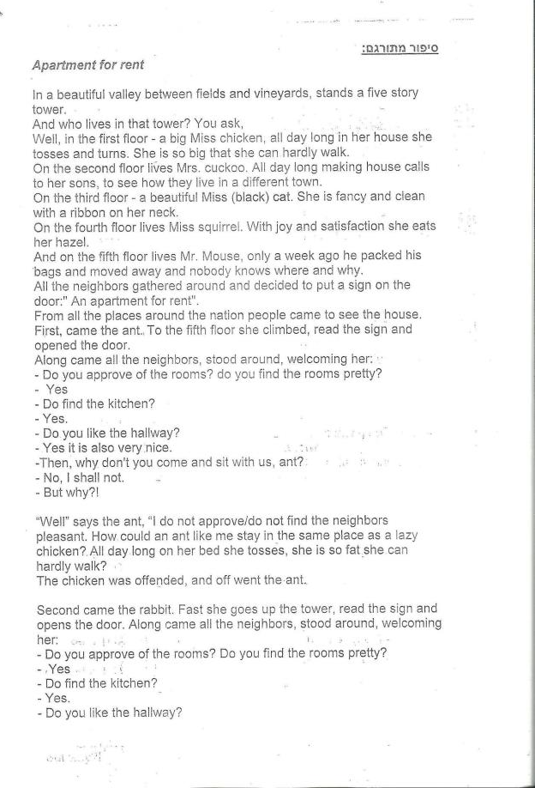

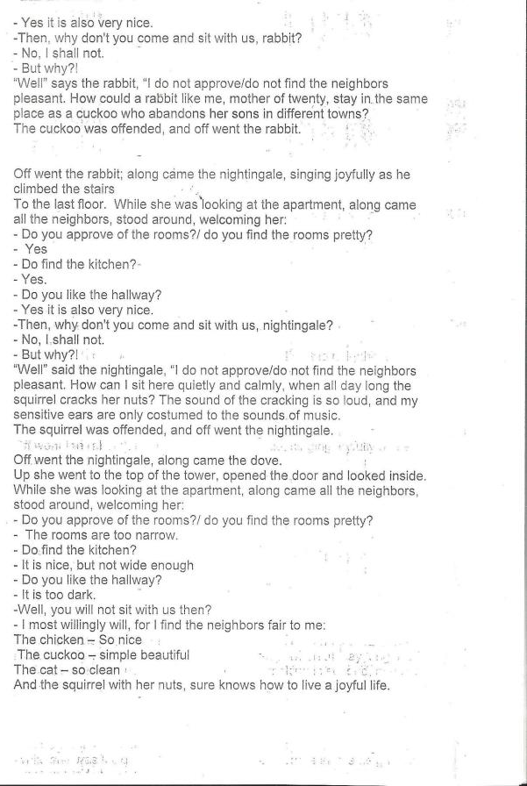

The Giving Tree
By Shel Silverstein
Once there was a tree
And she loved a little boy.
And every day the boy would come and he would gather her leaves and make them into crowns and play king of the forest.
He would climb up her trunk and swing from her branches and eat apples.
And they would play hide-and-go-seek.
And when he was tired, he would sleep in her shade.
And the boy loved the tree very much.
And the tree was happy.
But time went by.
And the boy grew older.
And the tree was often alone.
Then one day the boy came to the tree And the tree said, "Come, boy,
Come and climb up my trunk and swing from my branches and east my apples, and play in my shade and be happy".
"I'm too big to climb and play", said the boy. I want to buy things and have fun. I want some money. Can you give me some money"?
"I'm sorry", said the tree, "but I have no money. I have only leaves and apples.
Take my apples, boy, sale them in the city. Then you will have money and you will be happy".
But the boy stayed away for a long time and the tree was sad.
And then one day the boy came back and the tree shook with joy and she said, "Come boy, climb up my trunk and swing from my branches and be happy."
"I am too busy to climb trees", said the boy, "I want a house to keep me warm", he said. "I want a wife and I want children, and so I need a house.
Can you give me a house"?
"I have a house", said the tree.
The forest is my house, but you may cut my branches and build a house.
Then you will be happy".
And so the boy cut off her branches and carried them away to build his house.
And the tree was happy.
But the boy stayed away for a long time.
And when he came back, the tree was so happy she could hardly speak.
"Come boy", she whispered, "come and play".
I'm too old and sad to play", said the boy.
"I want a boat that will take me far away from here. Can you me a boat"?
"Cut down my trunk and make a boat", said the tree. Then you can sail away and be happy".
And so the boy cut down her trunk and made a boat and sailed away.
And the tree was happy but not really.
And after a long time the boy came back again.
"I am sorry boy" said the tree,
But I have nothing left to give you- my apples are gone".
"My teeth are too weak for apples", said the boy.
"My branches are gone", said the tree.
"You cannot swing on them"-
"I am too old to swing on branches", said the boy.
"My trunk is gone", said the tree. "You cannot climb"-
"I am too tired to climb", said the boy.
"I am sorry", sighed the tree. "I wish that I could give you something but I have nothing left. I am just an old stump. I am sorry"
"I don't need very much now", said the boy, "just a quiet place to sit and rest. I am very tired".
"Well", said the tree, straightening herself up as much as she could,
"Well, an old stump is good for sitting and resting. Come boy, sit down.
Sit down and rest".
And the boy did.
And the tree was happy.
The End.

A Tale of Five Balloons / Miriam Roth
Ruthi’s Mom brought a gift:
Happy and Joy – A balloon to every girl and boy
To Ruthi – a blue (cachol) balloon
To Sigalit – a purple (sagol) balloon
To Ron – a yellow (tzahov) balloon
To Uri – a green (Yarok) balloon
To Alon – a red (adom) balloon
All the children went for a walk with the balloons.

Uri was happy. He ran and jumped – and tossed the green balloon up above, with lots of love:
Tossed and caught it…tossed and caught , with the wind he fought
Down fell the balloon on the thorns it was torn
And suddenly…Boom! Trach!
Ma kara (what happened)?
The balloon popped and everything stopped!
Please – Uri – don’t be sad!
We will get you a balloon that’s new, so you will never again feel blue.

The Yeladim (children) Met Ron’s dad.
Ron was happy and said: dad– make yellow balloon bigger!
Big (gadol) – like your head! He said
like…like…the sun!!
Aba blew the Balloon…
And he blew…and blew…
Suddenly…Boom! Trach!
Ma kara? What happened?
The balloon popped and everything stopped!
Don’t feel sad Roni – Ron!
We will get you a balloon that’s new so you will never again feel blue.
The children met Mitzi –
Sigalit’s kitten soft as a mitten.
Siglit bent over, wanting to pet mitzi….
Mitzi grabbed sigalit’s purple (sagol) balloon – with its paw
Rolled it – and grabbed it…rolled it – and grabbed it…like a ball
Mitzi scratched the balloons with it’s nails.
And suddenly Boom! Trach!
Ma Kara? (what happened?)
The balloon popped …and everything stopped!
Don’t be sad sigalit! We will get you a balloon that’s new so you will never again feel blue.

That’s what happened to Ron. This is the end of every balloon.
The purple (sagol) balloon exploded.
The Yellow (tzahov) balloon exploded…
And also the green (yarok) balloon.
There are only two balloon left:
A blue (cachol) balloon to Ruthi
A red (adom) balloon to Alon.

Ruthi was afraid that her Balloon would explode…
Ruthi hugged the blue (cachol) balloon like you hug a doll…
Like you hug mommy (ima)

And suddenly…Boom! Trach!
Ma kara? What happened?
The balloon exploded. The balloon tore.
Don’t feel bad ruthi!
That’s what happened to Ron – that’s the end of every balloon.

There was only one balloon left – A red (adom) balloon – Alon’s balloon.
Suddenly…the wind blew hard – snatched the red (adom) balloon,
Blew it up, up above ---up to the clouds.

Alon waved and called:
Shalom! Shalom! (goodbye)
Balon adom! (red balloon)
The yeladim stood,
Waved their hands –
And called up to the sky:
Shalom! Shalom!
Balon adom!

My Father Embarrasses Me
Written by Meir Shalev

1) Once upon a time there was a boy whose name was Ephraim
He had a Mother who was a news reporter
Ephraim thought she was something special
He had a Dad that only made up stories
And always embarrassed him.

In the pool he never went in the deep water and just sat with a hat in the shade.

On the annual school trip for the preschool he got lost and didn’t even apologize.

2) At Aunt Batya’s wedding he came wearing shorts and in the restaurants he goes to peak in the pots and once he fell asleep in front of everybody on Parents Day. In the soccer game he caught the ball in his hands and to his son he gave the worst name - Ephraim.

3. Ephraim’s mom used to wake up early, drink coffee and grapefruit juice with a paper in her hand “Ephraim wake up your Dad so he will take you to the preschool, make-up, kisses and hurried to the office.
Ephraim’s Dad liked to sleep because of him Ephraim was always late for preschool.

It was very unpleasant to tell the teacher that Dad did not wake up on time.

4. On 8:15 he finally got up and for another half hour he was walking and looking around searching for his pants. Ephraim was mad “I told you a thousand times to organize your clothes the night before so they are ready in the morning”. It would be very unpleasant if someone came in and Dad was walking around in his underwear.

5. Dad drove him on his bike to the preschool and on the way he whispered to him about a midget who liked dresses but in the main street like always he started to sing out loud – it was very unpleasant. Ephraim didn’t know what to do – “sing quietly “Ephraim asked but dad sang out loud.
People looked, it was unpleasant. “Let me down a little bit before the preschool” but dad dropped him off right in front.

6. “Now give a kiss” dad bent over, Ephraim tried to explain to him he was in a hurry but then dad said loud enough so the other kids heard “if you are not going to give me a kiss I will ask one of the other Kids to give me one.”

“Don’t ask how he acts” said Ephraim to his mom ”right in front of the whole school it was so embarrassing “, Mom laughed and said “what can we do he loves to kiss, besides Ephraim it is what it is”.

7. The next day Ephraim’s dad took him to the movies; he also let him invite 2 friends. In the scariest part dad covered his eyes and said, “I’m afraid to look when they shoot. Ephraim tell me when it’s over”. It was very unpleasant Ephraim didn’t know what to do. “Don’t ask what he did in front of Uri and Dan “he told his mother “now everyone will say that my dad is a coward.”

8. At night in the dark before he fell asleep Ephraim laid in bed and listened to the sounds, a radio playing mom’s heels walking into the living room the window shades closing, down in the neighbors yard the cats are whining. A far away honk of a car horn, the refrigerator starts suddenly and in the other room his Dad on a typewriter pick-pick noisy sound does not let you sleep.

9. The next day the teacher announced there is going to be a celebration with all of the teachers and a contest, She asked everyone to bring a cake, but mom said she is busy she has an interview with the minister of tourism and she said “get some money Ephraim and buy a cake from the store”, He wanted to cry but dad said, “tonight I am not going to sleep I will make you a cake that will win 1st prize”. All night dad baked and woke Ephraim at 7:00 and showed him a not very beautiful cake – it was the size of a tire and kind of the same color.

10. “It’s a disgusting cake!” shouted Ephraim but dad already put his white chefs hat on and laughed “let’s go to the preschool” and exactly as Ephraim was afraid of all the dads sat on the chairs and his stupid dad in the stupid hat sat on the stage with all of the moms.

10. Rachelie’s mom with a strudel in a pan, Yael’s mom with sugary cupcakes, Micha’s mom with delicious smelling baklava, Yossi’s mom with yeast cake and Dan’s mom with a marzipan mold and everybody looked at Ephraim’s dad with a hat and a cake that took up half of the table.

11. The teacher took a knife and started tasting, she said mmmm and tsktstst with her tongue and then she got to dad’s cake and looked confused and curious altogether it was very unpleasant, a knife almost broke. “Just a minute “said dad “it’s my cake I am the only one to slice it”.

12. With the knife he just touched it and chocolate frosting came out the center of the cake 20 strawberries went up, he squeezed, pushed on the sides and sweet filling jumped out. Side to side he cut and pink cream spilled from the face of the side, a sugary lily bloomed – “OY” said everybody “hurray, hurray”

13. Then the teacher asked “who taught you to bake?”, “What do you mean, my dad was a cake expert other than baking he didn’t know what to do, he embarrasses me it was very unpleasant” “I didn’t know what to do – Shlomo’s dad was a policemen, Chaim’s dad was a doctor, Kalman’s dad was a picture-framer and my dad was a baker and that’s the hat I was hiding from him because I thought it wasn’t beautiful.”

14. And Ephraim, he was happy and also ashamed he was remorseful and also excited – so Ephraim said dad “will you take me home but give me a hand because I am a little bit afraid of the dark” everyone was laughing and Ephraim hugged his dad and finally he was comfortable - It Was Pleasant.

The End

