FALAFEL
In Israel, Falafel is the unofficial “national snack of Israel.”
Falafel is a traditionally Arab food that has been adopted by Israeli Jews. The word falafel may descend from the Arabic word falāfil, a plural of the word filfil, meaning ”pepper”. These fried vegetarian fritters are served in most Israeli restaurants along with hummus and tahini sauce (known as a “falafel plate.”) The idea of stuffing falafel into pita pockets is actually an invention of Yemenite Jewish immigrants to Israel. The introduction of falafel pita sandwiches made falafel portable, which expanded its popularity and made it into the number one “fast food” in Israel.
So just what is the history of this tasty little fritter? According to The Encyclopedia of Jewish Food by Gil Marks, “The first known appearance of legume fritters (aka falafel) in the Middle East appears to be in Egypt, where they were made from dried white fava beans (ful nabed) and called tamiya/ta-amia (from the Arabic for ‘nourishment’); these fritters were a light green color inside. Many attribute tamiya to the Copts of Egypt, who practiced one of the earliest forms of Christianity. They believed that the original state of humankind was vegetarian and, therefore, mandated numerous days of eating only vegan food, including tamiya.”
When falafel is made the traditional way, is indeed a vegan food; it’s a great source of protein for people who have cut meat out of their diet. It’s relatively low in fat and has no cholesterol if you fry it in heart-healthy grape seed oil. And if you top it with veggies in a pita, it becomes a filling and nourishing meal.
Falafel was originally made with fava beans and continues to be made that way in Egypt and other Arab countries, but Israeli falafel is made from chickpeas. This is because many Jews have a medical deficiency called G6PD, which is a hereditary enzymatic deficiency that can be triggered by fava beans.
You will need to soak dried chickpeas overnight for your falafel to turn out right; canned beans are too tender and contain too much moisture to achieve the right consistency. Don’t cook the beans, because this will result in a mushier and denser falafel, which is not the proper texture As we say in Israel, Bete’avon!

FALAFEL RECIPE
INGREDIENTS
1 pound (about 2 cups) dry chickpeas/garbanzo beans
1 small onion, roughly chopped
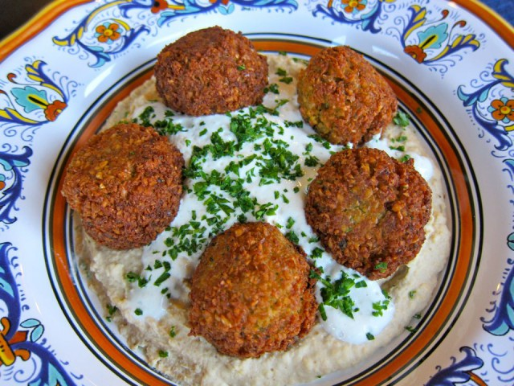
1/4 cup chopped fresh parsley
3-5 cloves garlic (I prefer roasted)
1 1/2 tbsp flour
1 3/4 tsp salt
2 tsp cumin
1 tsp ground coriander
1/4 tsp black pepper
1/4 tsp cayenne pepper
Pinch of ground cardamom
Vegetable oil for frying (grapeseed, canola, and peanut oil work well)
YOU WILL ALSO NEED: Food processor, skillet
Servings: 30-34 falafels
Kosher Key: Pareve
How to make FLAFEL – step by step:
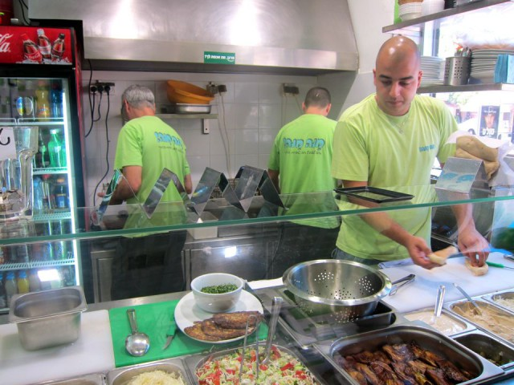

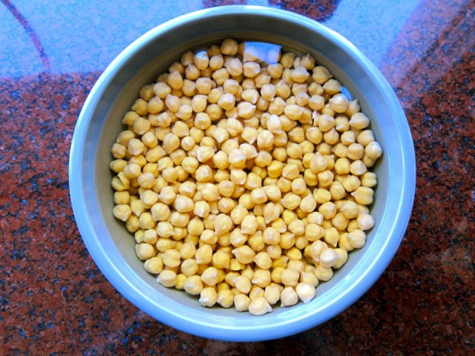
Pour the chickpeas into a large bowl and cover them by about 3 inches of cold water. Let them soak overnight. They will double in size as they soak – you will have between 4 and 5 cups of beans after soaking.

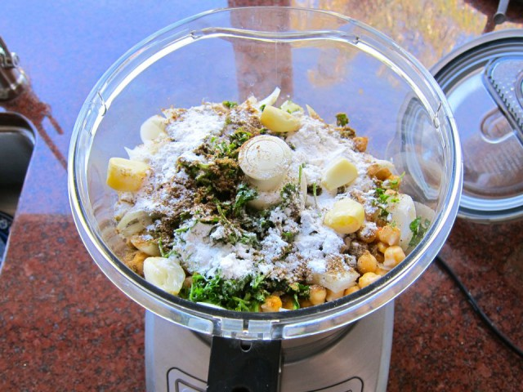
Drain and rinse the garbanzo beans well. Pour them into your food processor along with the chopped onion, garlic cloves, parsley, flour, salt, cumin, ground coriander, black pepper, cayenne pepper, and cardamom.

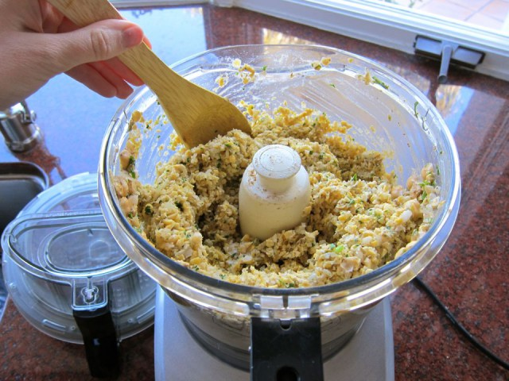
Pulse all ingredients together until a rough, coarse meal forms. Scrape the sides of the processor periodically and push the mixture down the sides. Process till the mixture is somewhere between the texture of couscous and a paste. You want the mixture to hold together, and a more paste-like consistency will help with that... but don't overprocess, you don't want it turning into hummus!

Once the mixture reaches the desired consistency, pour it out into a bowl and use a fork to stir; this will make the texture more even throughout. Remove any large chickpea chunks that the processor missed.

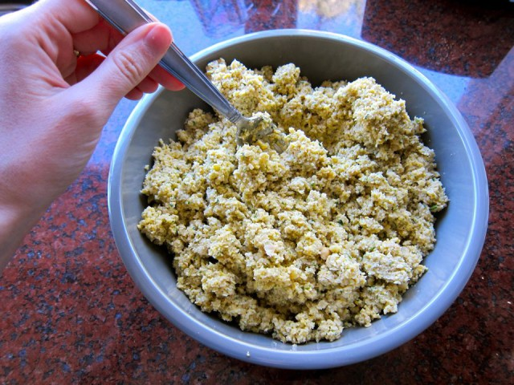

Cover the bowl with plastic wrap and refrigerate for 1-2 hours.
*Note: Some people like to add baking soda to the mix to lighten up the texture inside of the falafel balls. If you would like to add it, dissolve 2 tsp of baking soda in 1 tbsp of water and mix it into the falafel mixture after it has been refrigerated.
Fill a skillet with vegetable oil to a depth of 1 ½ inches. Heat the oil slowly over medium heat. Meanwhile, form falafel mixture into round balls or slider-shaped patties using wet hands or a falafel scoop. The balls will stick together loosely at first, but will bind nicely once they begin to fry.
*Note: if the balls won't hold together, place the mixture back in the processor again and continue processing to make it more paste-like.If they still won't hold, add 1-2 eggs to the mix. This should fix any issues you are having.

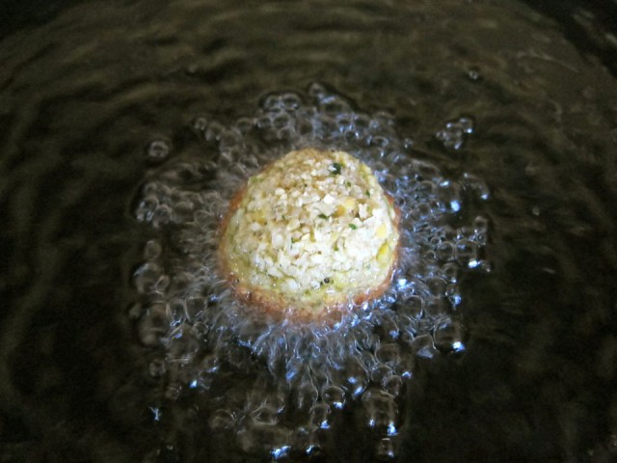

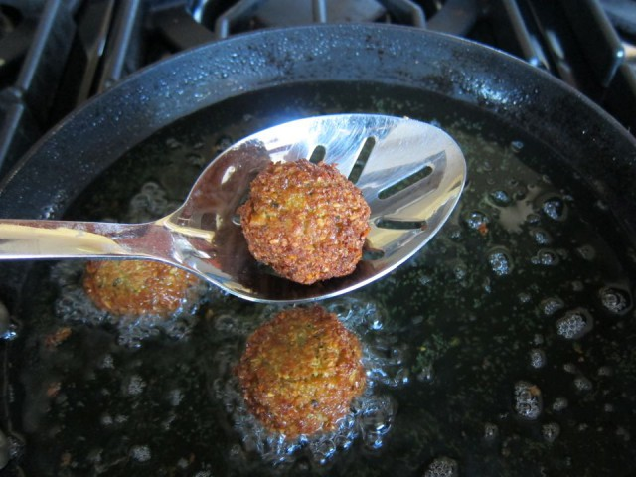
Before frying your first batch of falafel, it is recommend to fry a test one in the center of the pan. If the oil is at the right temperature, it will take 2-3 minutes per side to brown (5-6 minutes total). If it browns faster than that, your oil is too hot and your falafels will not be fully cooked in the center. Cool the oil down slightly and try again. When the oil is at the right temperature, fry the falafels in batches of 5-6 at a time till golden brown on both sides.

Once the falafels are fried, remove from the oil using a slotted spoon.
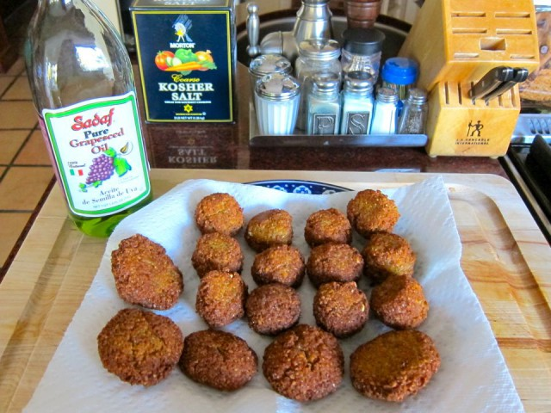

Let them drain on paper towels. Serve the falafels fresh and hot; they go best with a plate of hummus and topped with creamy tahini sauce. You can also stuff them into a pita.
*Troubleshooting: If your falafel is too hard/too crunchy on the outside, there are one possible reasons- you didn't process the mixture enough-- return the chickpea mixture to the processor to make it more paste-like.
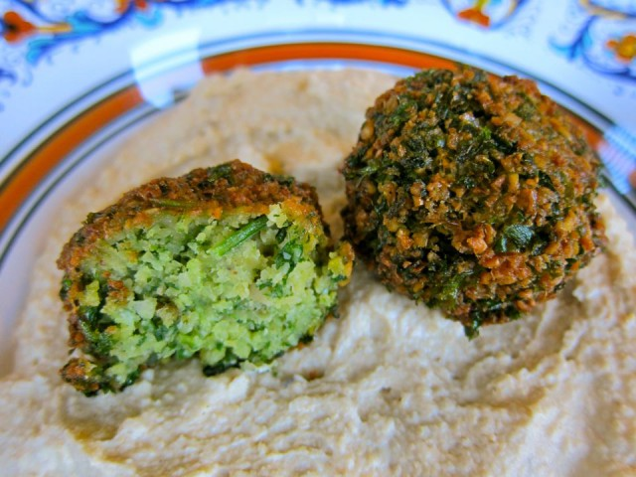

HERB FALAFEL VARIATION (GREEN FALAFEL): Add ½ cup additional chopped green parsley, or cilantro, or a mixture of the two prior to blending.

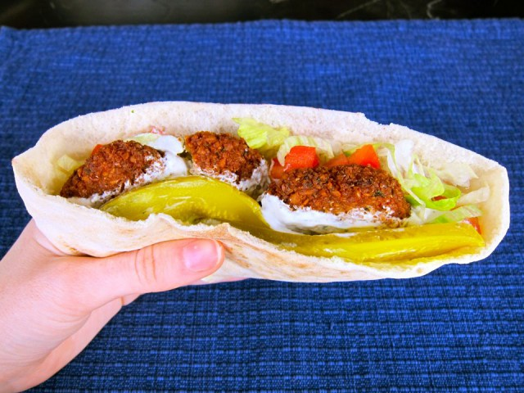

HOW TO MAKE A FALAFEL PITA?
Making a falafel pita is actually really simple. The two main ingredients are pita bread and falafel.
Cut the pita bread in half to form two “pockets.” Each pocket is a serving size. Stuff the pocket with falafel, as well as any add-ons you fancy. Here are some traditional add-ons that can be added to your pita; these are the ingredients most widely available at falafel stands throughout Israel:
Tahini sauce
Shredded lettuce
Diced or sliced tomatoes
Israeli salad
Onions
Dill pickles
Hummus
Tabouli
French fries

