Cherry tomatoes | Instant messaging
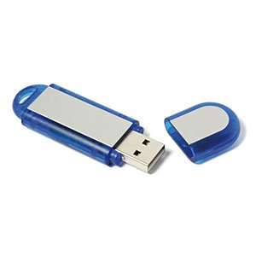  Memory stick | Solar water heating
Rummikub | Capsule Endoscopy  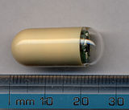
Cherry tomatoes were invented in Israel by Professor Nachum Keidar and the “ZERA” company.  The Cherry tomato was invented because there was a need for a type of tomato that will fit the Israeli hot weather and ripen slowly. | Instant messaging started in the 1970’s but wasn’t very good because it relied on other programs and every letter was sent the second you typed it.  3 young men invented ICQ  software which was a breakthrough and today all instant messaging (Facebook, Google, Skype etc.) are based on that software.
A USB flash drive is a data storage device that includes flash memory with an integrated Universal Serial Bus (USB) interface. USB flash drives are removable and rewritable. USB flash drives were invented by Amir Ban, Dov Moran and Oron Ogdan, all of the Israeli company M-Systems in April 1999. | The solar water heater is made out of a big water tank and a collector made mostly out of metal and glass and has a black pipe in it. The pipe takes the heat from the sun and keeps the heat inside (because it is black) and so warms up the water.
Rummikub was invented by Ephraim Hertzano, a Romanian-born Jew, who immigrated to Israel in the early 1930s. He hand-made the first sets with his family in the backyard of his home. The game combines elements of rummy, dominoes, mah-jong and chess. Hertzano sold the first sets door-to-door and on a consignment basis at small shops. Over the years, the family licensed it to other countries and it became Israel’s #1 export game. In 1977, it became a bestselling game in the United States. | The Capsule Endoscopy was founded in 1998 by Dr. Gabi Iddan and Dr. Gavriel Meron.  The capsule is a small pill with a camera inside it that a patient can swallow and the doctors could see using the camera the inside of the patient.  The idea for the solution was developed by Dr. Iddan, while working in the missile division of Rafael, where he thought that missile technology could be made smaller to create a medical product.

