Wine Regions in Israel
​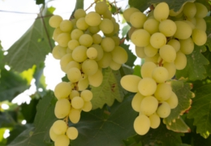
The ideal growing conditions for the cultivation of wine grapes lie in the two geographic strips between 30-50 degrees south and north of the equator. Israel is ideally situated in the Northern Hemisphere strip. Israel, like other 'long' countries such as Chile or Italy, enjoys a variety of microclimates. While the northern region gets much rain and even snow in the winter, just a few hours away, Israel's southern region is very arid with desert conditions. This range in microclimates supports many grape varieties, which can grow on several different types of soil, yielding excellent results. More than 90% of the Israel's vineyards lie in the Shomron, Samson & Galilee regions. The sub regions with the youngest vineyards are the Upper Galilee & the Judean Foothills.
The 5 Official Wine Regions of Israel:
- Galilee-Golan
- Shomron
- Samson
- Judean Hills
- Negev
Each one of Israel’s five wine growing regions awaits your exploration and looks forward to sharing its unique wines with you. As always in matters of taste, you must visit Israel’s wineries and vineyards and decide for yourself which is your favorite!​

Wine Making Revolution in Israel
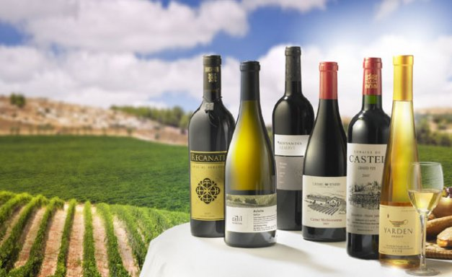
In the 1990’s, wine production which had been typically 70 % white, 30% red, changed to 60% red, 40% white, to reflect new tastes. International wine makers and consultants arrived to improve the overall quality- dealing with which types of grapes to grow, where to plant the vines and how to craft world class wines. Growers invested in state of the art equipment and modern techniques replaced less professional methods. It was during this time that a proliferation of wineries took place all over Israel. In fact, 85% of all operating wineries in Israel today were founded in the last decade!
There are currently over 25 commercial wineries and over 150 boutique wineries in Israel where wine making has become a personal obsession with wine makers striving to produce world class wines. This exciting surge in boutique ‘start ups’ notwithstanding, the three largest wineries account for 75 % of the annual harvest; the top 5 wineries total 84 % of the harvest, and the top 11 account for 95% of the total annual harvest.
Facts About the Wine Industry:
Vineyards
Hectares: 3,800 ha. (9,500 acres; 38, 000 dunams.)
Harvest 2005: 45,483 tons
Wine Market in Israel: $ 175 million dollars (20% imports.)
Consumption in Israel: 7 litters a head
2005 Export of Israeli Wines ($m): $ 13.8 million
Main Importers of Israeli Wines: 1. U.S.A; 2. France; 3. U.K.; 4. Germany; 5. Canada
Winemaking in Israel
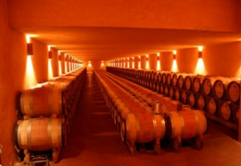
Brief History of Winemaking in Israel
The Middle East & Eastern Mediterranean was the cradle of wine production, and the ancient land of Canaan is in fact one of the earliest countries to cultivate wine, over 2,000 years before the vine reached Europe. In recent years excavations have uncovered ancient presses and storage vessels that indicate a well developed and successful wine industry existed throughout the area. Grapes, grape clusters and vines were frequent motifs found on ancient coins and jars. Many wine presses and storage cisterns have been unearthed - from Mount Hermon to the Negev. Inscriptions and seals of wine jars illustrate that wine was a commercial commodity being shipped in goatskins or jugs from ports such as Dor, Ashkelon and Joppa (Jaffa). The vineyards of Galilee and Judea were mentioned back then; while wines with names such as Sharon and Carmel from places like Gaza, Ashkelon and Lod were famous.

THE HISTORY OF ISRAELI WINE
Ancient Israel
Israel is the original “old world” wine region. The Middle East and Eastern Mediterranean was the cradle of the world’s wine culture thousands of years before the vine reached Europe.

WINE IN THE BIBLE
Wine has been produced in the Land of Israel since Biblical times. Whether you call it the Tanakh, Hebrew Bible, or the Old Testament, surely you are familiar with the story of the spies, Noah’s ark, or other Biblical stories that hark back to the original story of Israeli wine.
Ancient wine presses and wine making equipment are frequently found in archaeological digs. Often, these finds have even occurred at new wineries that have opened up only in the past decade.
In fact, wine making is thought to have originated in the area between the Black Sea, Caspian Sea, and Sea of Galilee. Noah was the first recorded viticulturist who, after the flood, “planted a vineyard.”
As the vine traveled throughout the Middle East and Mediterranean, the Jewish attraction to wine was shown in the developing literature.
The Bible also speaks of the Israelite kings have vast vineyards. King David’s wine stores were so vast that he had a special official just in charge of his wine. The vineyards of ancient Israel are mentioned throughout the Bible.
Excavations frequently uncover ancient presses and wine storage vessels from the Golan Heights to the Negev Desert. Grapes and vines were frequent motifs on coins and jars in ancient times.

RABBINIC TIMES
During the period of the Second Temple period winemaking was at its peak. It was a major export and economic mainstay. However, upon the destruction of the Second Temple and the dispersion of the Jews, the wine industry was forsaken. The Arab conquest in 600 CE further weakened the wine industry, due to Islam’s prohibition on alcohol. The wine industry in the Land of Israel lay dormant for another thousand years, until the return to Zion.
Rabbinic texts also speak of good wine. In fact, it is a mitzvah – a sacred commandment – to drink good wine on the Sabbath and Festivals.

Early Zionism

SHIVAT TZION: THE RETURN TO ZION
Despite the Babylonian exile, there has always been a small but continuous Jewish presence in the land of Israel. But the wine industry was tiny, producing just enough to satisfy Jewish religious needs, until the nineteenth century. But, in the late nineteenth century, there was an exploration of wineries, along with the beginning of Jewish immigration and the Zionist movement..
Despite its well-known brand, Carmel Winery is not Israel’s first winery, but is its best known brand and Carmel’s Rishon LeTzion winery, opened in 1890, is the longest continually-operating winery in Israel. The first recorded winery opened in 1848 by Rabbi Yitzhak Shor. Shor’s family remains in the wine industry today and Rabbi Shor’s descendents own the HaCormim, Arza, and Zion wineries.
In addition to the wineries owned by the Shor family, one of the earliest wineries was founded by Rabbi Avrom Teperberg in 1870. Efrat Winery (now known as Teperberg 1870) was founded in the Old City in Jerusalem, and has since been in several locations.

CARMEL WINERY BEGINS
In 1882, Baron Edmond de Rothschild commissioned a study to explore agricultural possibilities in the Land of Israel and two years later, those who turned to him for help, began producing grapes. This was the beginning of the Carmel Winery. In 1890, the winery in Rishon LeTzion was built. Two years later, a winery in Zichron Ya’akov was opened. Shortly after, huge underground cellars were built to ensure that the wine was stored at the proper temperature. But, it was not until 1895 that the Carmel Wine Company was formed to market the wines of Rishon LeTzion and Zichron Ya’akov Wine Cellars.
Since Carmel’s founding, it has been the “big boy” of Israeli wine and the best known international brand. In 1900, Carmel No. 1 won the Gold Medal at the Paris Exhibition, along with some of the finest chateaux of Bordeaux.

THE STATE OF ISRAEL IS ESTABLISHED
With the establishment of the State of Israel in 1948, numerous improvements were made. By 1948, vineyards only covered 17,000 dunam and there were fourteen wineries. Shortly after Israel’s independence, the Eliaz and Askalon wineries were founded. New areas were planted and, with waves of immigration, drinking habits changed. In the 1960s, advice from California was saught and new planting of varietals such as Cabernet Sauvignon and Sauvignon Blanc were made. It was not until 1971 that Carmel released Cabernet Sauvignon and Sauvignon Blanc for export.

Modern Times
In the early 1980s, the three biggest wineries were Carmel, Stock/WEST, and Eliaz.

CALIFORNIA EXPERTISE
In 1972, a visiting UC Davis professor suggested that the Golan Heights, acquired a few years previously in the 1967 Six Day War, would be a great place to grow quality grapes. Kibbutzim and moshavim then planted the first vineyards in 1976.
Yet, there were many difficulties in the 1970s and 1980s until Israel would begin making truly fine wines.

THE QUALITY REVOLUTION BEGINS
Yet, others were just starting to innovate. The Golan Heights Winery was founded in 1983. Israelis began to study winemaking abroad in places like California, France, Italy, and Australia.
In addition, families that had been involved in growing grapes for other wineries soon started to build their own wineries.
Israeli wine, most notably from the new Golan Heights Winery, also began winning international awards. The revolution was starting.

THE BOUTIQUE REVOLUTION BEGINS
In the late 1980s and early 1990s, individuals began opening their own wineries. Dr. Yair Margalit, a chemistry professor at the Hebrew University of Jerusalem, opened up Israel’s first boutique winery in 1989. Margalit also studied winemaking in California. Today, Margalit is recognized as making some of Israel’s best wineries.

