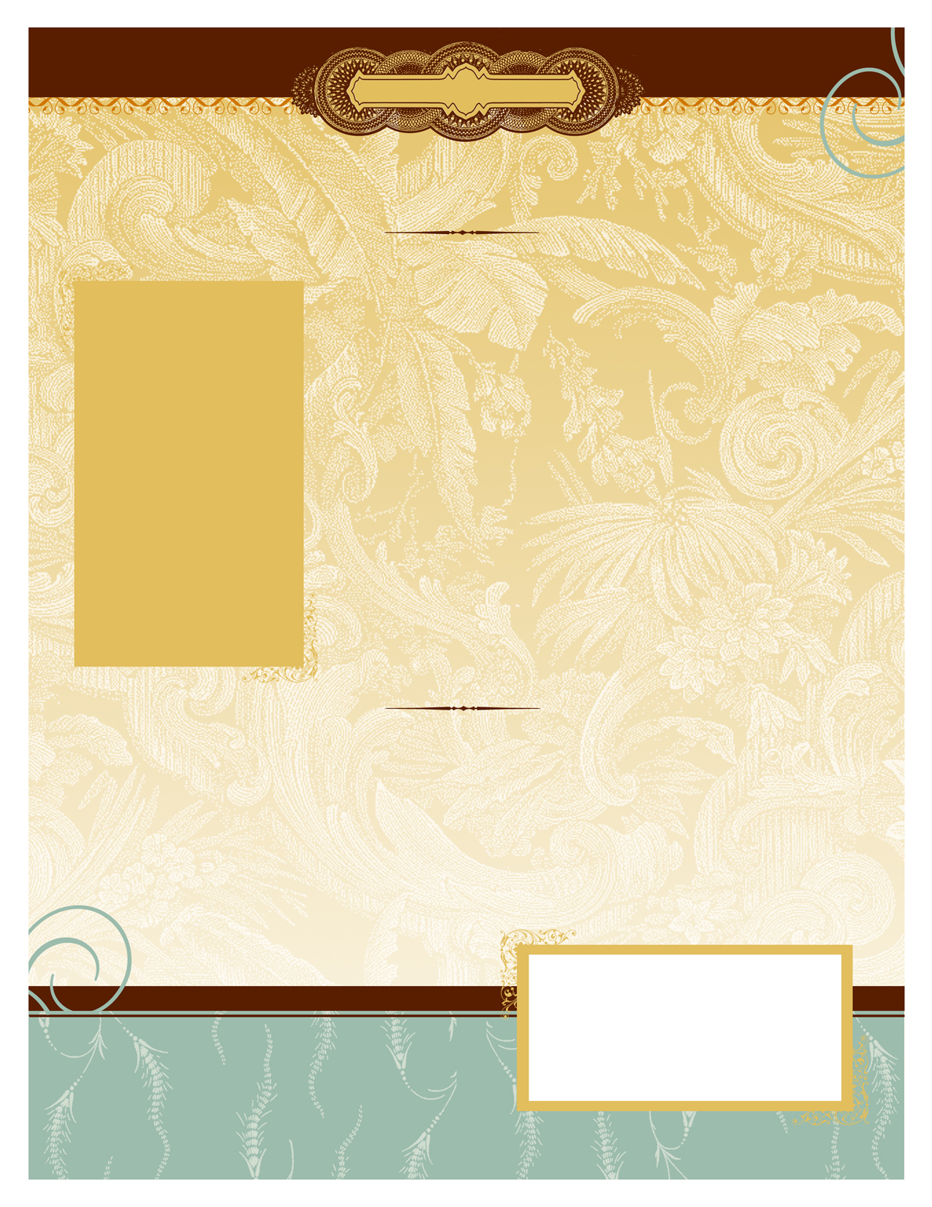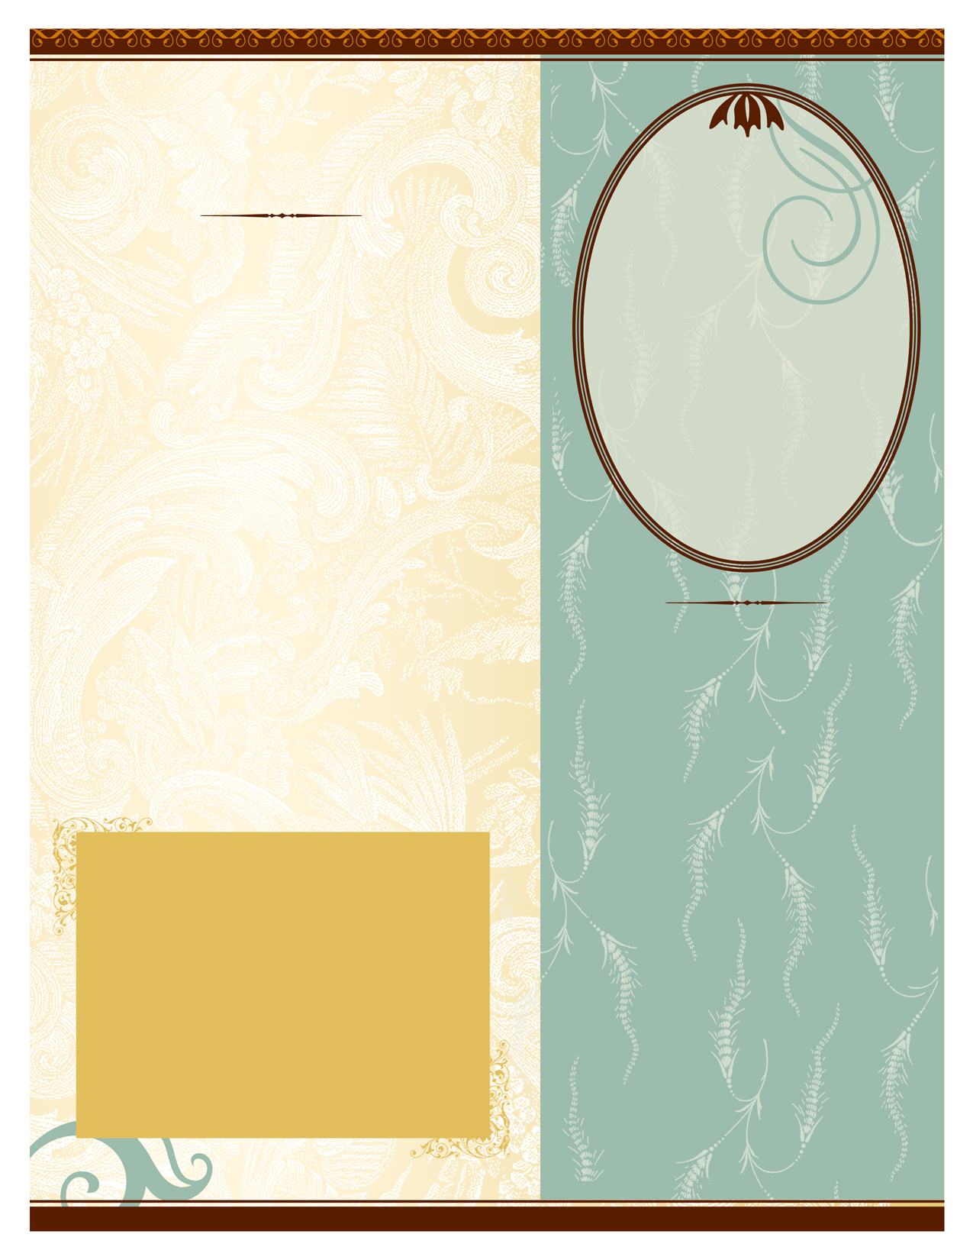

After settling in Israel, Jewish immigrants from North Africa celebrated Mimouna with their families in their communities.

In 1966, however, it was adopted as a national holiday, and has since been adopted by other ethnic groups. Mimouna is often celebrated with outdoor parties, picnics, and BBQs.

Mimouna also demonstrates the unity of Israel due to the custom of many not to eat in the homes of their neighbors on Passover because of personal stringencies pertaining to kashrut on the holiday. Moroccan, Tunisian and Algerian Jews open their homes to visitors. Those Jews go to one another's homes to celebrate and partake of food at the end of Passover to show that the nation's hearts are united.

**Mimouna expresses our hope to live in freedom and redemption**

Mimouna

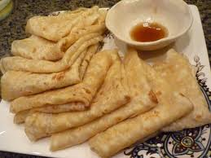

#### *תרבחו ותסעדו*

Mimouna is the post-Passover celebration of friendship, brotherhood, and unity that is observed in Moroccan Jewish communities. It is a twenty-four hour celebration which begins immediately with the conclusion of Passover. It is viewed by many as the formal return to “chametz” (leavened bread) after such foods was forbidden over the course of the holiday. The theme of Mimouna is good fortune, fertility, wealth, and prosperity.

There are a number of theories as to the origins of the name “Mimouna” with an emphasis on a continuation of Passover themes. Some says that the name Mimouna derives from the Arabic word for “wealth” and “good luck” or from the Hebrew word “emuna” or “ma’amin” both of which mean “faith” or “belief”, which reflect Mimouna as a celebration of faith and trust in God. This is closely related to Passover in general and the crossing of the Red-Sea in particular, which took place on the last (7th) day of Pesach. It was at the crossing of the Red-Sea that the entire nation witnessed the awesome power and might of God which was an experience that strengthened their “emuna” (faith).

**A Moroccan style celebration at the end of Pesach**

**Mimouna Table**

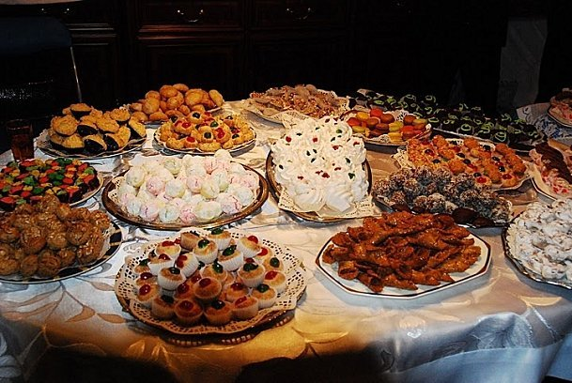

**Moufletta – Family Recipe**

2 pounds of flour, 4 tablespoons of active, dry yeast

3 cups of warm water, 1/4 cup vegetable oil, a pinch of salt.

Combine all the ingredients in a bowl. (Add the salt at the end)

Divide the dough into 30 to 40 small balls.

Heat some oil in a large skillet over a low flame.

Flatten the individual balls of dough with your hands.

Fry each pancake over low heat. When one side turns golden, flip it over and fry the other side.

Spread each Moufletta with butter and honey. Roll it up like a cigar.

“When you bite into a Moufletta

it will be hot, soft, buttery, and sweet. You will experience a feeling of well-being and contentment”!

**"Why is the table set this way?**

The answer can be found in the name of the holiday and in the songs traditionally sung on the day. The Arabic word Mimouna means luck or good fortune. At the Mimouna celebrations, songs are sung in honor of "Lady Luck." One of them is "Lala mimouna/ barka masuda," which means "Lady Mimouna/lucky and blessed." Lady Luck is being feted with a table laden with goodies symbolizing abundance, health, success and good fortune.

Mimouna table offers a hint of the holiday's true origins. It is not set for a family dinner, as usual, but displays an array of symbols that are basically variations on a theme. On this table you will not find typical Moroccan cuisine. It is laden neither with meat dishes nor an assortment of salads. Instead, it is laid out with items, each of which is symbolic in some way: a live fish swimming in a bowl of water, five green fava beans wrapped in dough, five dates, five gold bracelets in a pastry bowl, dough pitted with five deep fingerprints, five silver coins, five pieces of gold or silver jewelry, a palm-shaped amulet, sweetmeats, milk and butter, white flour, yeast, honey, a variety of jams, a lump of sugar, stalks of wheat, plants, fig leaves, wildflowers and greens. BUT the food that says “Mimouna” the most is certainly the Moufletta, a type of pancake closely resembling the Mallawach Spread with butter and honey and rolled up like a cigar. All are symbols of bounty, fertility, luck, blessings and joy. The traditional holiday greeting fits right in: "Tarbakhu u-tsa'adu" - meaning, "May you have success and good luck."