מהו גיבור- פעילות
1- Divide the group in to 4 smaller groups (or according to the number of tables). As a team, draw /write what is/ who your Hero. It has to be built from each individual’s heroes. (What are their characteristics?)
2- Present your Heroes to the everyone- Discuss as a group what makes a person a hero.
3- Each group gets a picture, name and bio of a person. Each group reads about their person and writes down as a group why or why not he is a Hero. (Heroes from the holocaust and also modern Israel)
4-Present it to everyone.
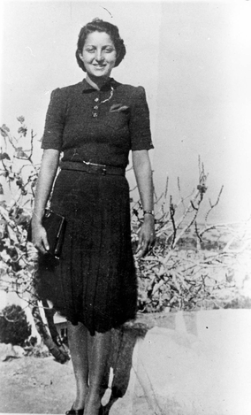

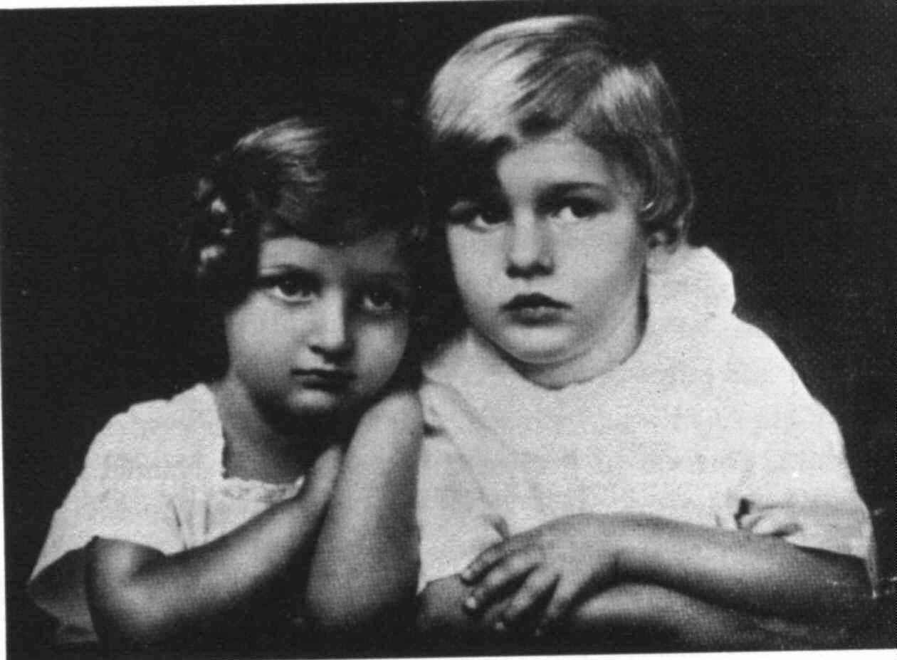

Hanna Szenes

Szenes was born on July 17, 1921, to an assimilated Jewish family in Hungary. Her father, Béla Szenes, a journalist and playwright, died when she was six years old. She continued to live with her mother, Catherine, and her brother, György (Giora).
She enrolled in a Protestant private school for girls that also accepted Catholic and Jewish pupils; most of those of the Jewish faith had to pay three times the amount Catholics paid. However, Senesh only had to pay twice the regular tuition because she was considered a "Gifted Student". This, along with the realization that the situation of the Jews in Hungary was becoming precarious, prompted Szenes to embrace Zionism, and she joinedMaccabea, a Hungarian Zionist students organization.

Immigrating to Nahalal
Szenes graduated in 1939 and decided to emigrate to what was then the British Mandate of Palestine in order to study in the Girls' Agricultural School at Nahalal. In 1941, she joined Kibbutz Sdot Yam and then joined the Haganah, the paramilitary group that laid the foundation of the Israel Defense Forces. In 1943, she enlisted in the British Army in the Women's Auxiliary Air Force as an Aircraftwoman 2nd Class and began her training in Egypt as a paratrooper for the British Special Operations Executive (SOE).

Arrest and torture
On March 14, 1944, she and colleagues Yoel Palgi and Peretz Goldstein were parachuted into Yugoslavia and joined a partisan group. After landing, they learned the Germans had already occupied Hungary, so the men decided to call off the mission as too dangerous. Szenes continued on and headed for the Hungarian border. At the border, she and her companions were arrested by Hungarian gendarmes, who found her British military transmitter, used to communicate with the SOE and other partisans. Hannah was taken to a prison, stripped, tied to a chair, then whipped and clubbed for three days. She lost several teeth as a result of the beating. The guards wanted to know the code for her transmitter so they could find out who the parachutists were and trap others. Transferred to a Budapest prison, Szenes was repeatedly interrogated and cruelly tortured, but she only revealed her name and refused to provide the transmitter code, even when her mother was also arrested. They threatened to kill her mother if she did not cooperate, but she held firm (and probably saved her mother's life as a result).
While in prison, Szenes used a mirror to flash signals out of the window to prisoners in other cells and communicated using large cut-out letters that she placed in her cell window one at a time and by drawing the Magen David in the dust. She tried to keep their spirits up by singing, and through all the things Szenes went through she still kept her spirit high and stayed true to her mission.

Trial and execution
She was tried for treason on October 28, 1944. There was an eight-day postponement to give the judges more time to find a verdict, followed by another postponement, this one because of the appointment of a new Judge Advocate. She was executed by a firing squad She kept diary entries until her last day, November 7, 1944 when she was executed by a German firing squad. One of them read: "In the month of July, I shall be twenty-three/I played a number in a game/The dice have rolled. I have lost," and another: "I loved the warm sunlight."
Her diary was published in Hebrew in 1946. Her remains were brought to Israel in 1950 and buried in the cemetery on Mount Herzl, Jerusalem. Her tombstone was brought to Israel in November 2007 and placed in Sdot Yam.
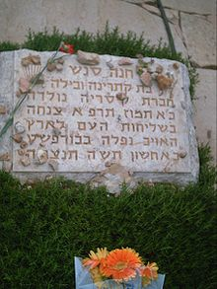
After the Cold War, a Hungarian military court officially exonerated her.

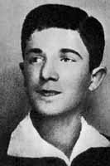
Mordechai Anielewicz
(1919 – 8 May 1943) was the leader of the Jewish Combat Organization, also known as ŻOB, during the Warsaw Ghetto Uprising from January to May 1943.

Biography
Anielewicz was born into a poor Jewish family in the small town of Wyszków, near Warsaw. After he completed his high school studies, he joined and became a leader of the "Hashomer Hatzair", the Zionist-socialist youth movement.
On 7 September 1939, a week after the German invasion of Poland, Anielewicz escaped with a group from Warsaw to the east of the country in the hopes that the Polish Army would slow down the German advance. When the Soviet Red Army invaded and then occupied Eastern Poland in accordance with the Molotov–Ribbentrop Pact, Anielewicz heard that Jewish refugees, other youth movement members and political groups had flocked to Vilna, which was then under Soviet control. He travelled to Vilna and attempted to convince his colleagues to send people back to Poland to continue the fight against the Germans. He then attempted to cross the Romanian border in order to open a route for young Jews to get to the Mandate of Palestine, but was caught and thrown into a Soviet jail. He was released a short time later, and returned to Warsaw in January 1940 with his girlfriend, Mira Fuchrer.
In the summer of 1942, Anielewicz visited the southwest region of Poland – annexed to Germany – attempting to organize armed resistance. Upon his return to Warsaw, he found that a major deportation to the Treblinka extermination camp had been carried out and only 60,000 of the Warsaw Ghetto's 350,000 Jews remained. He soon joined the ŻOB, and in November 1942, he was appointed as the group's chief commander. A connection with the Polish government in exile in London was made and the group began receiving weapons from the Polish underground on the "Aryan" side of the city. On 18 January 1943, Anielewicz was instrumental in the first act of the Warsaw Ghetto Uprising, preventing the majority of a second wave of Jews from being deported to extermination camps. This initial incident of armed resistance was a prelude to the Warsaw Ghetto Uprising that commenced on 19 April.
Though there were no surviving eyewitnesses, it is assumed that he died on 8 May 1943, along with his girlfriend and many of his staff, at the surrounded ŻOB command post at 18 Miła Street. His body was never found and it is generally believed that it was carried off to nearby crematoria along with those of all the other Jewish dead; nevertheless, the inscription on the obelisk at the site of the Miła 18 bunker states that he is buried there.

Honors
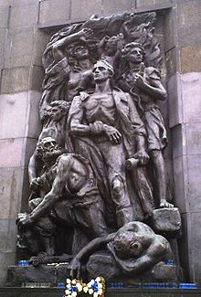
During the later part of the war, a unit of the People's Guard formed from Warsaw Ghetto survivors bore the name of Anielewicz. In December 1943, kibbutz Yad Mordechai in Israel was renamed after him and had a monument erected in his memory.

Warsaw Ghetto Heroes' Monument in Warsaw
(Anielewicz is in the center, wielding a hand grenade)

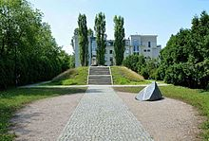
General view of Miła 18 memorial in Warsaw,
place of death of Mordechai Anielewicz

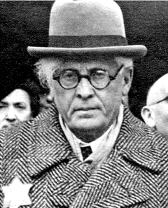

Rumkowski, Mordechai Chaim

(1877--1944), Chairman of the Judenrat in the Lodz ghetto in Poland. Formerly an unsuccessful businessman and an orphanage director, Rumkowski was appointed Judenrat chairman on October 13, 1939, after the German invasion of Poland. Like all Judenrat heads, Rumkowski was torn between helping the Jewish population in the ghetto survive, and giving in to the demands of the German authorities. Rumkowski, however, is considered to be one of the most controversial of all Judenrat leaders, in that he often cooperated with the Germans and treated the Jews of his ghetto dictatorially.
Rumkowski reported directly to the German ghetto administration, which was headed by Hans Biebow. He was completely responsible for everyday life in the ghetto: providing food, housing, heat, work, and health and welfare services for the suffering ghetto population. Rumkowski controlled all aspects of the ghetto, even its cultural life. When rabbis were forced to stop working, he himself began performing marriages. His picture even appeared on the ghetto's money. Rumkowski was also responsible for setting up 120 factories, which employed thousands of the ghetto’s Jews, all employed in producing goods for the Germans. Rumkowski believed that if he could create a productive and vital work force for the Nazis, then they would not destroy the ghetto.
Rumkowski also believed that in order to save the ghetto as a whole, he would have to cooperate with the Nazis and give in to their deportation demands. By the end of 1941, the extermination camp at Chelmno had been established and the Germans forced Rumkowski to organize the deportation of a portion of the ghetto population. Initially, Rumkowski tried to convince the Germans to reduce the number of Jews to be deported. However, the
Germans refused and made Rumkowski responsible for deciding who was to be deported. During the first 5 months of 1942, 55,000 Jews from Lodz were sent to their deaths at Chelmno.
During the second week of September 1942, another deportation was carried out. The Nazis demanded that Rumkowski turn over all children and old people. He cooperated with their demand and calmly asked families to surrender their children. Twenty thousand Jews were brutally rounded up and sent to Chelmno. Subsequently, there was a respite from the deportations, strengthening Rumkowski in his belief that keeping the peace and working for the Germans, would help prevent further deportations. During that period of time, the Lodz Ghetto was left alone while other ghettos all over Poland were being destroyed.
However, by the late spring of 1944, the Soviet army was advancing toward Lodz. The Nazis decided to liquidate the Lodz Ghetto. Rumkowski was forced to arrange the deportation. From June 23 to July 14, 1944, approximately 7,000 Jews were sent to Chelmno. The Jews of Lodz resisted the deportations passively, leading the Nazis to decide to liquidate the ghetto immediately, with SS and German police units carrying out the evacuation.
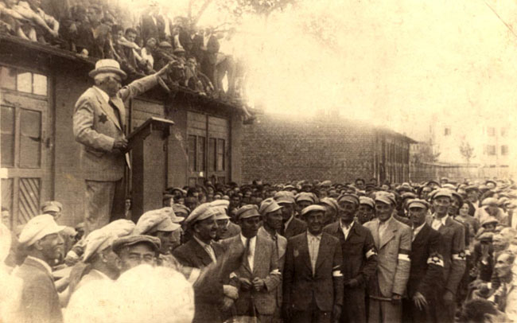
The Germans closed the ghetto's factories and dissolved all Judenrat-run institutions. The Jews were now taken to Auschwitz. Rumkowski encouraged the Jews to calmly report for deportation, but they ignored his request. The Germans completed the liquidation of the ghetto in late July and August, sending the Jews to their deaths. Only a few hundred Jews managed to hide successfully. Rumkowski and his family were not spared---they were deported to Auschwitz on August 30, 1944, and were murdered there. Lodz was liberated by the Soviet army on January 19, 1945. Some historians view Rumkowski as a collaborator and traitor. Others believe he made a serious, yet flawed, attempt to rescue as many Jews as possible.

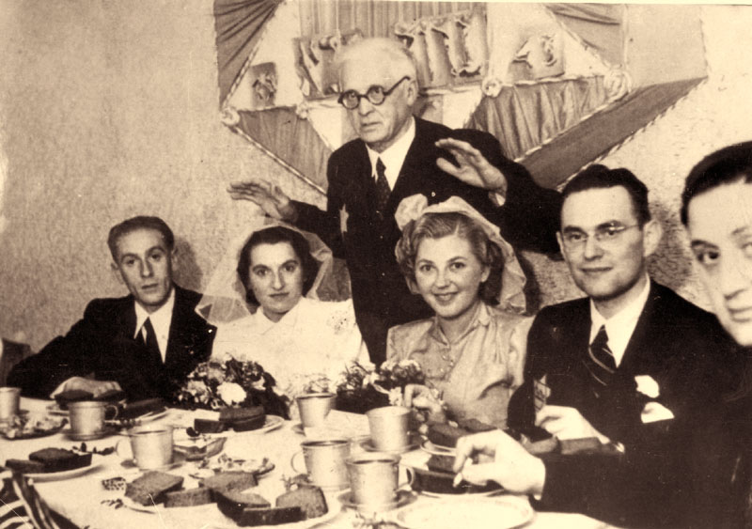

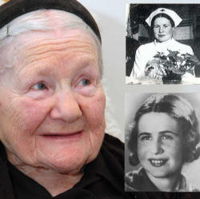

Irena Sendler

Born in 1910, in Poland.
She was a social worker, a Catholic Nurse, when the Nazis invaded Poland.
When the Jews were rounded up into the Warsaw Ghetto, Irena joined the Polish underground sponsored movement, Zegota (Council to Aid the Jews), and became the head of its division on children.
She obtained a pass from the Nazi Epidemic Control Department so she could enter the Ghetto. Seeing the starvation conditions and knowing that death was the final outcome for Ghetto residents, she began smuggling the children out. She hid them in toolboxes, potato sacks, gunny sacks, even coffins.
The church was an active assistant. One church had two doors, one on the Ghetto side and the other on the "Aryan" side. The children entered the church as Jews and exited as Christians, with false documents. Sendler reported that she sent most of the children to religious establishments because she knew that she could count on the sisters.
The children were given false identities and placed in adoptive homes, orphanages, and convents. Irena later stated that no one had ever refused to take a child from her. Even though, in Poland, anyone found aiding a Jew would be executed with his entire family.
Irena noted the children's original names and their new identities, and buried the records in jars beneath an apple tree in a neighbor's back yard, across the street from German barracks. She hoped that she could someday dig up the jars, locate the children and inform them of their past.
In all, the jars contained the names of 2,500 children.
In 1943 Irena was arrested, imprisoned and tortured by the Gestapo, who broke her feet and legs. In spite of the torture, Irena did not betray the identities of any of the adoptive families, her associates, or the Jewish children.
She was sentenced to death, but escaped and lived in hiding for the rest of the war.
After the war she dug up the jars and tried to reunite the children she had placed with their natural relatives. Sadly, most of the Jewish families had perished during the Holocaust.
Irena's story was unnoticed until the year 2000, when four high school students in Kansas wrote about her as part of a history project.

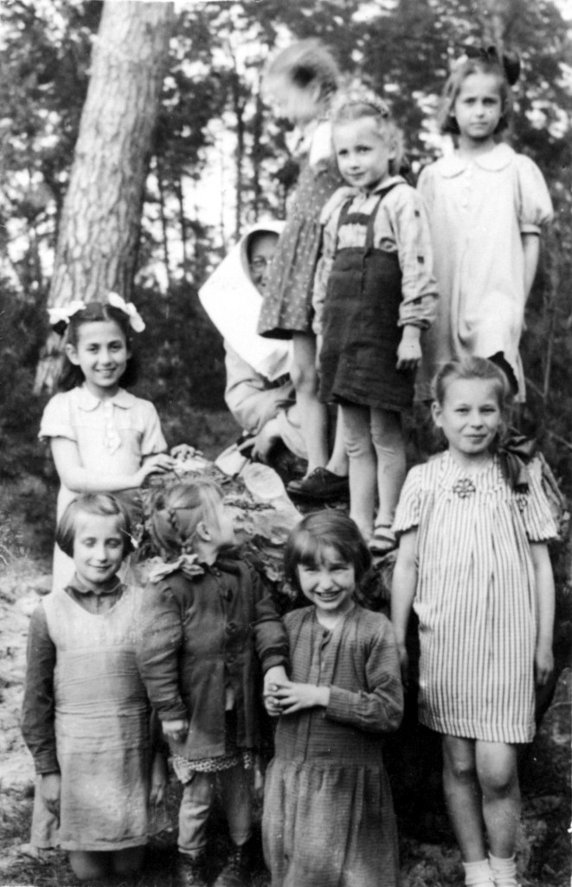
“Every child saved with my help is the justification of my existence on this Earth and not a title to glory.” – Sendler’s letter to Polish Parliament

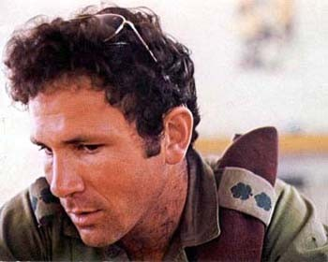
Jonathan (Yoni) Netanyahu
When Yoni was born on March 13, 1946 in New York City,
his parents, Benzion and Cela, were working on behalf of the
New Zionist Organization.
Shortly after Yoni turned two, his parents returned to their homeland, now the newly created state of Israel but later on moved back for Yoni’s father could do further historical research.
In June 1964, following his graduation, Yoni returned to Israel. His family was to remain in America for the coming years, frequently visiting Israel. Upon being drafted into the Israeli Defense Forces for his obligatory military service, Yoni volunteered for the paratroopers. He proved to be a superb soldier. He was sent to Officers’ Training School, from which he graduated first in his class. Yoni then became a platoon commander in the paratroopers. With the growing escalation of terrorist attacks from across the borders, he saw action in a retaliatory raid on a PLO stronghold in the West Bank, then held by Jordan.
In January 31, 1967 Yoni was discharged. He had already been accepted to Harvard University for the fall of 1967. In May of 1967 dramatic events were unfolding in the Middle East. War was imminent, and Yoni, along with numerous other reservists, was mobilized. When war finally broke out on June 5, Yoni took part in the fierce and pivotal battle of Um Katef at the Sinai. On the last day of the war he was wounded in his arm, while reaching out to help a wounded comrade. He managed to crawl back to the Israeli lines, and upon reaching them, fainted. His left elbow remained permanently disabled.
He then left for the USA and while he enjoyed his studies at Harvard, in which he excelled, he felt increasingly that his place was not there. Israel was in the midst of fighting a “War of Attrition” against Egypt and Jordan and of combating terrorism in its towns and cities. At such a time, Yoni believed, he should be in his homeland, near the site of battle. And so in the summer of 1968, he and his wife returned to Israel.
He decided to enlist once more in the army. Both his brothers had by then returned to Israel, and Benjamin (Bibi) had become a veteran soldier in Israel’s elite commando unit, Sayeret Matkal (known briefly as “the Unit”). Yoni applied for membership in the same unit. He was immediately accepted and assumed the command of a squad. In the summer of 1972 Yoni was promoted to deputy commander of the Unit.
Yoni served during the Yom Kipur war 1973 and was awarded a distinguished service medal and in June 1975, he became commander of Sayeret Matkal and was in charge of many operations. Of these, all but one remain secret –the raid on Entebbe.
On June 27 an Air France airliner, whose flight originated in Israel, was hijacked over Europe by Arab and German gunmen. The plane eventually landed in Entebbe, Uganda, where President Idi Amin was waiting for the terrorists and received them with open arms. The hostages were kept captive at the Old Terminal of the Entebbe International Airport, held under guard by the terrorists and by a contingent of Ugandan soldiers. The terrorists warned that if their demands to release from jail more than fifty terrorists were not met, the hostages would be killed.
On July 1, Yoni received orders to plan and prepare his unit for the mission to Entebbe. At the stroke of midnight, Ugandan time, on July 4, 1976, the first plane landed at Entebbe airport. A brief battle developed with the Ugandans and the terrorists, following which the terrorists in the building were killed and the hostages freed. During the battle, Yoni was hit in the chest, as he ran forward, and lay critically wounded outside the main hall where the hostages were held.
The efforts of the medical team to revive Yoni were of no avail, and he died at the entrance to the evacuation plane, as the hostages were being herded inside. Yoni was the only man of the rescue force to die. (Three out of the 106 hostages were killed during the exchange of fire and a fourth was later murdered by Idi Amin’s men.) Yoni’s body was placed inside the plane, which then took off to safety in Kenya. From there it proceeded to Israel.

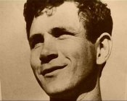

Roi Klein

(July 27, 1975—July 26, 2006) was an Israeli major in the
Golani Brigade of the Israeli Defense Forces (and one of
its most highly decorated soldiers) who died during the
2006 Lebanon War. Klein was killed in the Battle of Bint Jbeil after jumping on a grenade to save his fellow soldiers.
Klein was born in Raanana, Israel. His parents, Aharon and Shoshana Klein, were Holocaust survivors. His father's side originated from Germany and fled to then, Palestine at the onset of World War II. Most of his mother's family was killed in the Holocaust.
Klein studied Industrial Engineering and Management at Ariel University Center of Samaria, and graduated with honors.
Klein lived in a home he built on his own in the Hayovel community, near Eli, Mateh Binyamin. He was married to Sara and had two sons: Gilad and Yoav
Klein began his IDF service in the Paratroopers Brigade but later transferred to the Golani Brigade's Egoz Reconnaissance Unit. In 2002, Klein received a Chief of Staff Citation for his conduct during an ambush near Nablus .
At the time of his death, Klein was the deputy commander of the 51st Battalion of the Golani Brigade. During the Battle of Bint Jbeil, a hand grenade was thrown over the wall that was between Hezbollah militants, and Klein and his unit. Klein jumped on the live grenade and stopped the explosion with his body. The soldiers reported that Klein recited the Jewish prayer, Shema Yisrael, as he jumped on the grenade. According to other accounts he yelled "Long live Israel."
Roi Klein became a symbol for heroism in Israel.
For his actions during the war Klein received the Medal of Courage posthumously.

