Dear Friends!! ☺
BZ, Mizpah, Chabad, CJCRS, Jew Crew, YJL and Hadassah.
Yom HaZmaout Let’s decide on a spelling that becomes the standard for the entire office (Independent day for Israel)is getting here very soon!
We want to have a big Israel festival for the community’s kids!
Each school/group will get a city from Israel and will need to build a station about it. For the station each school/group will have to learn about the city, have information to share about the city in a fun way which can include a game / art or craft / or any other activity. It will be on Sunday, April 19 at the Jewish Cultural Center, between 9:30AM-12:30PM
With a lot of help from you – it will be amazing and a fun event!
We will have snacks, Israeli music, and the kids tour the stations.
I have a list of cities that you can choose from – on a first come basis. Don’t wait .Pick as soon as possible.
The choice of city depends on you. If you won’t decide until March 1st , I will let you know which city you will do.
I picked non-familiar cities so the kids can learn more about Israel.
You can think of your own creative ideas for this project, just keep me posted. Please confirm your ideas with me to ensure they are a good fit for the program.
Need some help to get those ideas following? Just give me a call.
Here are the cities (with a sample of some ideas):
- Beer Sheva / Negev - colored sand bottles, water transfer from place to place (because there is no water in the Negev, we need to save every drop)
- Tzfat - religious city, building a Jewish Mosaic
- Caesarea - building ancient construction, or singing karaoke on the stage of Caesarea
- Mount Hermon (Snowy) - skating on plastic bags
- Dead Sea, the lowest place on earth – Limbo game
- Kibbutz - milking a cow and squeezing orange juice
2 more cities that will be at the festival (but are already taken care of ):
- Tel Aviv - A photo pictures in Tel Aviv (Green Screen) – YJL responsibly
- Jerusalem - The Western Wall (write wishes) – NOA responsibility

Thank you so much!!! I’m really excited about it!!
Have a great day!

Yom Ha’aTzmaout – Kids Program
Event: April 19 at the Jewish Cultural Center

PLEASE RETURN THE FORM TO ISRAEL@JEWISHCHATTANOOGA.COM BY MARCH 27

10:00 Open Ceremony: Tekes (תמאוהעצ יום טקס)Yom Ha’aTzmaout
10:30-11:30: Time at the Stations
11:30: Human Israel flag (?) or large closing ceremony

Name of organization: B’nai Zion

Contact Name: Jason Cathcart

Preferred Phone Number: 423-894-8900

Selected city in Israel: Be’er Sheva

Describe what will take place in the station. Include what educational materials you will have for the children:
- Ben Gurion University of the Negev – learning and activity about Ben Gurion’s belief in building the Negev
- Focus on chess and its importance to the area
- Negev Museum of Art – learn about the art housed there and make a piece of art to take home
- Be’er Sheva’s beach and the importance of water to the area

What equipment, if any will you bring:
TBD

What equipment and how many of each (tables, electricity) will you need from the Federation?
Two tables, 6 or 8 feet long

How much space will you need?
About a 10x10 foot square

Names of the volunteers at your station:
TBD

Any other requests? If you are requesting that the Federation purchase or reimburse you for some of your supplies, please state the type of supply, where you intend to purchase it, and cost. Noa will respond to your request no later than April 2.

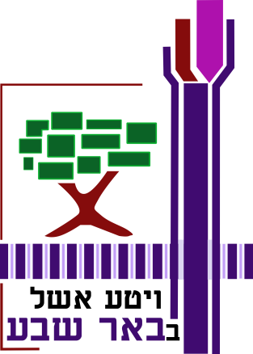  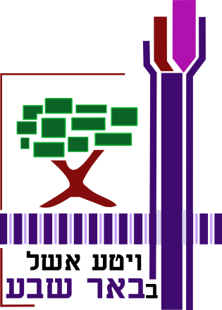 |  | 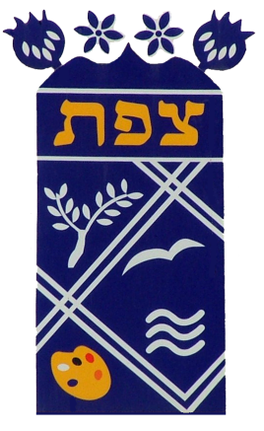
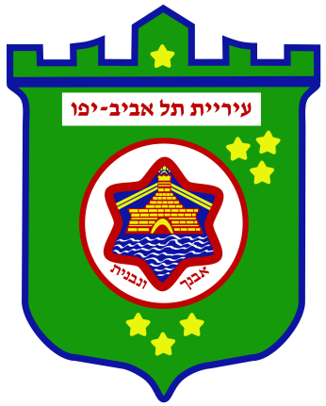  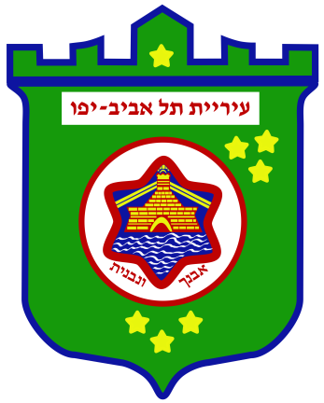 |  | 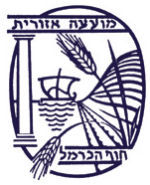
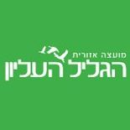 |  | 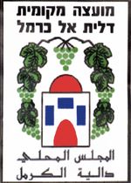
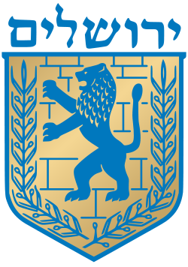 |  | 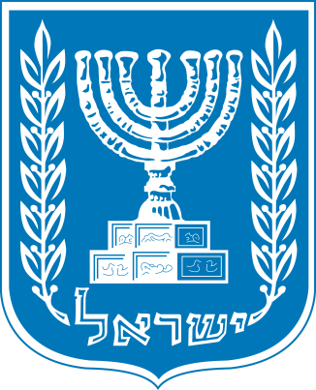
 |  | 