Israel and the Holocaust
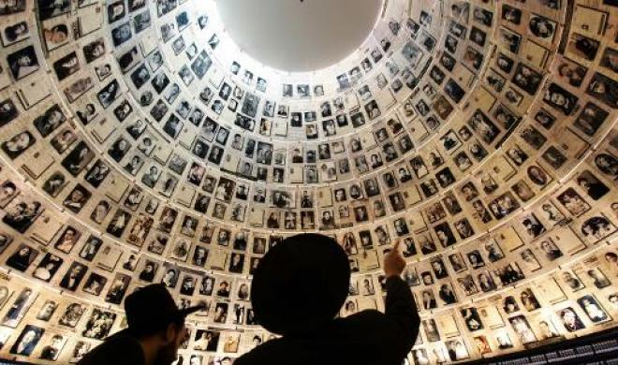
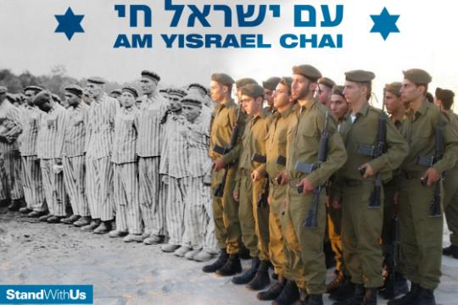
How the Holocaust affects Israeli society
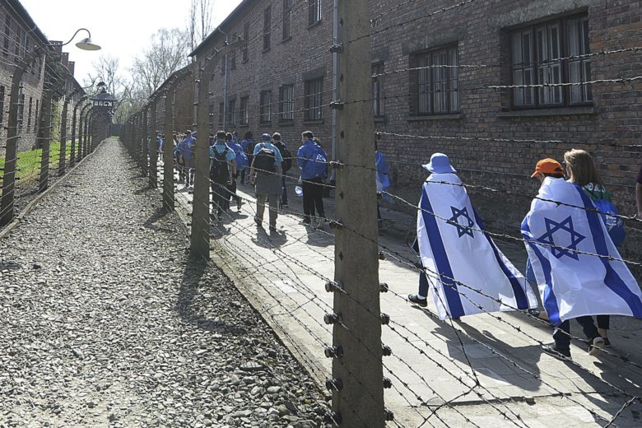
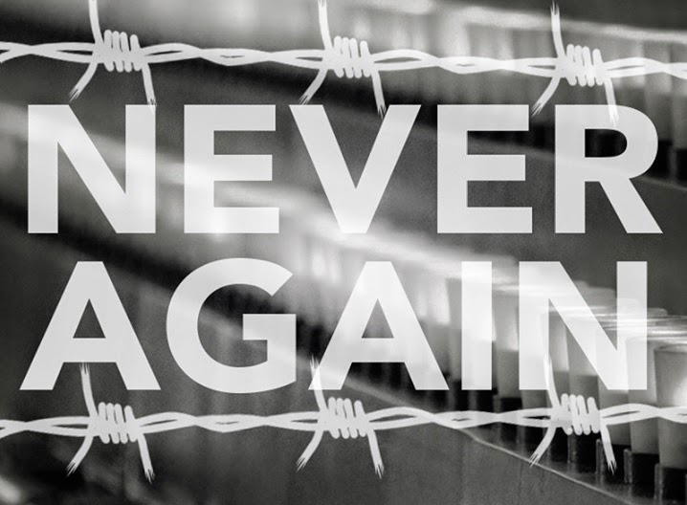

“Without memory, there is no culture. Without memory, there would be no civilization, no society, no future.”
Elie Wiesel, Romanian-American Holocaust Survivor, Writer, Politician and Nobel Laureate, 1928-2016

Dear Livnot-nik,
Welcome to the Second educational pack that we are sending you.
At the end of January we will mark the international Holocaust Memorial Day. The Holocaust is a huge topic and will not be discussed in detail in this pack. Instead, we will focus on what happened after the holocaust, and how even more then 70 years on it still shapes the lives of Israelis and Jews around the world.
In this pack, we will discuss Israeli society and culture, and how it has been and still is affected by the events of the Holocaust.
This pack will first provide a general overview of the history of Holocaust commemoration in Israel and how Israeli society view the holocaust.
In the second part, we will take a look at some opinion articles about the way Israel remembers the holocaust and is constantly affected by it. These different opinions and difficult questions should provide a useful opportunity to challenge us.

This pack will be used as a background to the session we will have in London and in Manchester on this topic. For this session we are bringing an outside speaker, and so we won’t be using the pack in the same way as usual. Still, we encourage you to read it and get a better understanding of the situation is Israel, before the session.

We hope you find this useful.
See you soon!

Your Movement Team

Israel and the Holocaust- Until 1961:
The impact of the Holocaust on Israel began even before the establishment of the state. In 1945, when the magnitude of the murder started to become apparent, close to 90% of the Jews living in pre-state Mandate Palestine had lost a close relative. This caused the Jewish community there to unite in a revolt against British rule. The goal was to force the British to allow survivors to enter the country and to advance Jewish statehood in Palestine.
Despite the large number of Holocaust survivors in Israeli society in its early years, the subject of the Holocaust was not extensively dealt with educationally during the state’s first decades. At the time, there was a need to engender a fighting ethos to meet the military challenges facing Israel. Viewed from the Israeli perspective then, it appeared that the Jews in Europe had gone to their deaths “like sheep to the slaughter,” therefore the state emphasized the heroism displayed by the participants in the ghetto uprisings, as well as the partisans who fought the Nazis. These were framed as Zionists (who wanted to make it to pre-state Israel), whose ideological values had given them the courage and convictions to fight against all odds.
In 1949, The first Holocaust Remembrance Day took place on December 28th, a year and a half after Israel's independence. The ashes and bones of thousands of Jews were brought over from the Flossenbürg Concentration Camp near Munich. They were placed in a crypt, together with decorated Torah scrolls, in a Jerusalem cemetery.
In 1952, Israel, the Jewish Claims Conference and West Germany signed the “Payments Agreement.” The Germans agreed to pay restitution for Jewish slave labour and property stolen from Jews under Hitler. Although the agreement was controversial in Israel (“money for the blood of our relatives?” etc.) it was ratified by the Parliament. Over the course of 14 years, West Germany paid Israel three billion marks, in goods, industry and monetary instruments. Since the Israeli economy had no inherent means of survival in the 1950s, this significant economic infusion enabled the country to build a modern industrial infrastructure.
In 1953, the Knesset passed a law creating Yad Vashem, the official Israeli memorial institution for the Holocaust victims. On that year’s Holocaust Remembrance Day, schools were instructed, for the first time, to discuss the subject with their pupils.
In 1955 Yad Vashem began documenting the victims of the Holocaust. Israel's entire leadership - the government, judges, parliamentarians and other dignitaries – took part in that year's memorial event, in the memorial forest planted outside Jerusalem.
In 1959, the Knesset passed a law officially establishing Holocaust Memorial Day in law and sanctioning official ceremonies throughout the country as well as a two-minute moment of silence, indicated by sirens. In 1961 the Knesset amended the law, to close down cafes, restaurants and clubs on the 27th of Nissan.
It was only in 1961, when Eichmann went on trial in Jerusalem that Israeli society as a whole began to take intense interest in the Shoah. Survivors were encouraged to give testimony and to tell their stories publically; the Israeli population was glued to their radio-sets as the trial was broadcasted. For many, it was the first time they had heard the details of the Holocaust.
Israel and the holocaust: Six days war until today:
In 1967, on the eve of the Six Days War, many Israelis feared that the threatening Arab armies of Egypt, Syria and Jordan would bring another Holocaust on the Jewish people.
In 1973, During the Yom Kippur War, Israelis watched on television for the first time as soldiers were being taken into captivity as POWs. The sense of helplessness led many to empathize with the Holocaust survivors in their midst and what they had endured. In the aftermath of the war, the Israeli educational system began to treat the subject of the Holocaust as a central part of Jewish history and devoted more time to its study.
In the late 1980s, Israeli schools began to send their students on missions to Poland, with an emphasis on visits to Nazi extermination camps like Auschwitz and Majdanek as well as Jewish life in pre-WWII Poland.
In the mid-1990s, the IDF created a program known as “Witnesses in Uniform,” which brings soldiers on educational trips focusing on Jewish heritage and the Holocaust in Poland. There has been a lively public debate about the educational goals and efficacy of these travel seminars to Poland. One of the critiques has been about the focus on a particularistic view of the lessons of the Holocaust; that Israel needs to be a strong Jewish state; that the approach that emphasizes a strong commitment to fighting racism and prejudice to prevent future genocides is frequently neglected.
In recent Israeli history, the Holocaust has played both invisible and visible political roles. In the 1980s Israel had two Prime Ministers who had virtually lost their entire biological families in the Holocaust: Menachem Begin and Yitzchak Shamir. One can only conjecture the impact Begin’s family history had on him when he decided to send the air force to bomb an Iraqi nuclear plant in 1981. In the past few years, Prime Minister Benjamin Netanyahu has repeatedly invoked Holocaust imagery in the public discourse on what Israel’s policy should be towards Iran’s aspirations to achieve a nuclear device.
Two very different “lessons” have been culled from the Holocaust by Israeli society. One approach takes a particularistic stance, declaring “never again” regarding the Jewish people. The other lesson is universal and seeks to prevent the genocide of anyone, anywhere, ever again.

The Holocaust in the Israeli culture and Arts:
The Holocaust is central to the Israeli culture. Unlike most historical events whose influence gradually recedes, it is fair to say that the influence of this series of events on Israeli society has actually increased with the passage of time. Large sectors of Israeli society – the mainstream, the decision-makers and the cultural icons – were emotionally ‘blocked’ for decades in their attitude towards the Holocaust. The main reason for this is that it was difficult for many Israelis – and for the society as a whole – to face this period in Jewish history without the protective, ideological armour of a Zionist perspective that condemned the victims even as it mourned them. The prevailing activist stream in Zionism perceived them as having ignored the warning signs, as ‘sheep to the slaughter.’ For years, this patronizing attitude prevented many Israelis from understanding the complexities of the true situation that the Jews of Europe had faced. The Zionists chose to memorialize instead the memory of the proud fighters of Warsaw and other ghettos. In such an atmosphere, it is hardly surprising that – apart from those who had had direct contact with the Shoah – the subject was kept at a distance and intellectualized by much of Israeli society. It is safe to say that this stage – which may be called ‘Stage One’ of Israeli Holocaust memory – lasted until well into the 1970s.
The change started to happen after the Eichman trial in 1961. For the first time, Holocaust survivors were encouraged to come forward as witnesses and retell their experiences openly before the Israeli public. As this occurred, the Israeli society began not only to acknowledge the Shoah in their heads but also to feel it in their hearts. The empathy that previously had been lacking in many Israelis now became evident and the entire subject became acceptable. This is evident in Israeli creative culture. For example, judging by the ideological position represented in some of the early Israeli art on display at Yad Vashem, the official national site of Shoah commemoration, Israeli artists and writers have clearly become more empathetic.
The Israeli cinema generally has not focused on the Shoah. Two important feature films that tackled the subject of survivors in the early years of statehood, however, should be mentioned. Both were made by Israel’s leading film actress, Gila Almagor; drawing on her personal memories as the daughter of a survivor family, she created two truly wonderful, empathetic pictures in the 1980s and 90s. The Summer of Aviya(1988) and Underneath the Domim Tree (1995) possess deep emotional power and are two of the finest Israeli films. Another, very different, film is the full-length documentary Because of That War. This portrays the extraordinary attempt of rock musician Yehuda Poliker and his partner Yaakov Gil‘ad, both children of survivors, to write rock songs about the Shoah, chronicling their parents’ experiences.
A large number of other documentaries have been made on this subject. With time, however, the emphasis has changed. At first statements were made on a large scale, not only in film and literature, but also in monumental art such as the powerful Scroll of Fire, situated in the Judean hills around Jerusalem. In recent years, however, these have tended to be replaced by smaller, more personal statements. Many documentaries have now been produced in which survivors record the details of their daily lives and recount their personal history.
In some ways, the weight of this memory is becoming heavier with the passage of time. Clearly this subject will be part of the Israeli psyche and its artistic expression for many years to come.

^{Holocaust Survivors in Israel:}
The effects of the Holocaust are still felt by survivors today. Their experiences have impacted both their physical and mental health and wellbeing, further influencing their children and families.
During Israel’s War for Independence, tens of thousands of survivors entered the country and many joined the army. By the end of the war, close to 50% of the Israelis in uniform were survivors. In 1960, 25% of the Israeli population were Holocaust survivors.
Today, more Holocaust survivors live in Israel than anywhere else in the world. Of the approximately 186,000 Holocaust survivors in Israel, about 60,000 live in poverty.
There are several factors that contribute to these survivors’ situation. Though Germany pays retribution to survivors, those who moved to Israel after 1953 do not receive these benefits. This is in part because the agreement was signed between Israel and Germany in 1952, and the Israeli government decided to compensate only those who moved to the Holy Land prior to 1953 when payments began.
Today, charity organizations often take upon themselves the responsibility of caring for these people.
In 2014, then Finance Minister Yair Lapid passed a NIS 1 billion “National Plan to Assist Holocaust Survivors.” This increased the allowances of survivors to those who came to Israel before 1953. Nonetheless, the large number of poverty-stricken Holocaust survivors remains as many are stuck in bureaucratic red tape. These elderly and, often, lonely people continue to suffer hunger and depressing living conditions.
Second and Third Generation:
In Israel the survivors went on to raise families and their children are known as “second generation.” Over 500 studies have shown the psychological impact of the Holocaust on the second generation. On the one hand, this population has suffered from post-traumatic stress disorder. On the other hand, the second generation actively participated in Israel’s wars, helping to create a fighting ethos for the Jewish state. Recently, a study showed that third generation — grandchildren of survivors — suffer more emotional stress than the overall population.

Opinion: Did the State of Israel Come About Because of the Holocaust?
Elly Dlin
DID MORE THAN 2/3rds VOTE FOR THE PARTITION BECAUSE OF THE HOLOCAUST?
Whilst politicians often used the Holocaust in their rhetoric and made reference to it in their speeches, it is naive to assume that decisions taken in the plenum of the United Nation are based mainly on moral, humanitarian and historical concerns. In a world in which states have neither permanent friends nor permanent enemies, only permanent interests, one should not underrate the role of self-interest.
The British Empire was fading. The Indian sub-continent was gaining political independence at the very same time as Israel and without having gone through a Holocaust. The Russians and their allies may have dreamed of a pro-Marxist base in the Middle East from which they could advance their program for world revolution. Fishing in troubled waters offered them more hope for successes than a region that was stable.
DID THE STATE OF ISRAEL COME ABOUT BECAUSE OF THE HOLOCAUST?
It is true that the British were getting quite bad press from their mishandling of the Jewish refugee issue. Their naval training exercises were totally disrupted as the most powerful fleet in the world was using up precious fuel rations to chase down little boats crammed full of refugees. The Cyprus camps were full and there was no longer any convenient place to send more Jews. No one wanted them and the decision to send them back to where they came from - Germany - was a grave error in public relations. Even the fiasco of the EXODUS, 2 more ships holding 15,000 more “illegal immigrants” were making final preparations to set sail for the Land of Israel. Meanwhile there was an increasingly popular uprising in Palestine of Jews who were determined to kick out the British occupation troops.
But the State of Israel did NOT come about because of the Holocaust! 2,000 years of yearning and prayer and 50 years of intensive Zionist activities preceded it and was essential to the State becoming a reality. Imagine the Holocaust happening BEFORE a single kibbutz was built, before a flourishing Jewish culture had been re-established in Israel, and without armed Jews fighting to defend themselves in the Land. Would anyone have supported Jewish sovereignty in that situation? Surely not!
If anything the Holocaust almost destroyed the natural hinterland of the Zionist movement and nearly “solved” the Jewish problem in a lethal fashion. Had the Nazis fulfilled their intentions and all of the Jews of Europe and the Middle East had been murdered in the Death Camps would anyone have argued for the pressing need of an Independent Jewish State for the Jews of America or Australia?
But even more so, the State of Israel did NOT come about because of the Holocaust because it did NOT come about as a result of a resolution passed in New York. Had the Jews lost the 1948-9 War of Independence, no Jewish State would exist; and the Holocaust played no significant role in the military victory over the Arabs.
At most the Holocaust was a contributing factor to the timing and circumstances of the struggle for independence. It certainly affected the kind of Jewish State that was created, its population mix, its self-perception and its world view; but the events that underpin its creation are located elsewhere.

Opinion: Would Israel have become a nation if the Holocaust had never happened?
Khalid Elhassan, Quara
Probably not. The Holocaust, and its prelude and aftermath, supercharged European Jewish immigration to the British mandate of Palestine, and that migration played a critical role in the foundation of Israel.
Without that push factor driving Jewish immigration to Palestine, it is unlikely that the Jewish population would have grown and reached a critical mass sufficient to successfully fight a war of independence.
It wasn’t just a question of raw numbers of European Jewish refugees boosting the pre-existing Jewish population in Mandate Palestine. It was also, for purposes of the war of independence, the fighting quality of many of those refugees: a lot of them had combat experience from the war as partisans/ resistance fighters, had formal military training and experience in the various Allied armies that fought in WW2, or had otherwise survived the hardships being a Jew in WW2 Europe, whether in concentration camps or on the run from the Nazis.
So in that sense, the Holocaust brought an influx of Jewish migrants who, collectively, were more combat experienced and/or hardened than the opponents they would soon face. And, looking back at what they had just experienced in Europe and might be forced to go back to if they failed, more highly motivated.
Also, absent the Holocaust, it is unlikely that there would have been as much international support for a Jewish state in Palestine as happened in the aftermath of WW2.
So in a nutshell, it is unlikely, or at least significantly less likely, that Israel would have been founded if not for the Holocaust.

Opinion- Playing the Holocaust card
Varda Spigel’ the times of Israel:

The 2nd generation lives with the rough hand it was dealt, and deserves sympathy, compassion, help and understanding
I have heard and read this hateful and dismissive phrase over and over again during the past week. The ubiquitous call to Jews to shut up already about the Holocaust pervades social media hate talk throughout the year and particularly as Jews around the world gear up in May for Holocaust Remembrance Day and the March of the Living from Auschwitz to Birkenau. Those who fear that the Holocaust might justify Israel’s right to exist accuse Jews and particularly Israelis of “playing the Holocaust card” to achieve nefarious ends.
Here’s the thing about playing the Holocaust card: For me and many like me, children and grandchildren of Holocaust survivors, the Holocaust is not a card. It is the hand we were dealt. And Holocaust Remembrance is not a day. It is a lifetime.
Let me say up front that I would not — Heaven forbid — compare our suffering to that of our parents and grandparents, whose numbers are dwindling, and who openly express yearning for an end. I am, however, begging those who demand that we get over ourselves to reconsider.
Like most 2Gs, what we children of survivors call ourselves, I woke up as a toddler and throughout my childhood to the screaming nightmares of my parents. I rifled through the lingerie drawer of my mother’s best friend, who promised herself as a teen that if she survived Auschwitz, she would buy only the best. And I watched her roll up a piece of wedding cake in the hem of her dress, when Alzheimer’s forced her to relive the Holocaust until her death.
I will not forget that each and every person on the planet holds cards, backstories, reasons to shed tears prompted by injustice and war. Nor will I forget that each and every one of us is entitled to play those cards and the hand that he or she was dealt — to ask for sympathy, compassion, understanding, and help.
I am merely asking for the same. I am begging those who would deny me to let me play the Holocaust card. Because the Holocaust card is mine.

Opinion- Stop Holocaust-Based Identity!
Yaacov Selavan, times of Israel:
As a grandson of a survivor and an IDF Captain, I find banal ceremonies and “Never Again” declarations ineffective. After leading an IDF march into Auschwitz-Birkenau, I understood the magnitude of our educational failure.
“In Poland I feel Jewish, I can’t explain it – I feel more Jewish, only here do I put on tefillin.”, the opening of our first daily debriefing by our Lt. Colonel, a dedicated and devoted commander. This was the atmosphere of the entire trip – Poland defines our identity. Our whole purpose, the essence of our existence and of our military service is “Never Again”.
The Israeli education system and the IDF fail to build a strong and proud Jewish identity among teenagers. That failure affects their motivation as young adults to serve our people and country in significant roles, especially enlisting for combat. Israel’s official remedy for treating this failure has become Poland and the Holocaust. I witness this personally. Dozens of soldiers under my command singled out their high school visit to Poland as the key reason for drafting to combat service. My friend recalled that when he was debating if to extend his service his commander sent him to Poland. As he was landing back in Israel this colonel called when he was coming into the office to commit for more years.
If Poland is the cure to this educational failure, I don’t want any part of it. We need to find better ways to justify our existence here and to strengthen our sense of mission in the IDF. It is impossible to base an entire moral infrastructure on one event or epoch, as tragic as it is.
Two months ago my grandfather, Ben Hirsch, passed away, the last of 5 survivor siblings. So my daughters won’t hear about the Holocaust first-hand like I did from him. The survivors are disappearing, and the next generation of Israelis and Jews might see the Holocaust as something ancient and irrelevant, like… Tisha B’Av.
For the respect we have for Holocaust memory to endure we must stop using it as the ultimate motivational source, and rather as a seminal event in our long history as the nation of Israel; a history of thousands of years, tragedies and triumphs, full of values and virtues.
Israel is now a strong, flourishing country, a Start-Up nation. It is time to find better ways to strengthen the sense of connection to the IDF mission, and to justify our existence here. It is time to stop connecting everything to the tragic fate of the Jews, and instead to look ahead with vision and a common destiny, true to our roots and timeless values.

Questions for discussion:
- Why do we need 2 holocaust memorial days- International one on January and national one on April?
- How do you think the holocaust affects Israel?
- How do you think the holocaust affects Israelis?
- How big of a part does the holocaust play in our identity?
- Does Israel play the holocaust card too much or not enough?
- Would Israel exist without the holocaust?
- How can we explain or understand holocaust denial? And what does that say about antizionism?
- Should the events of the holocaust affect Israel’s policies when it comes to refugees? (“Never again”)
- What do you think about the survivors’ situation in Israel?

