“Honey, cancel Netflix,
We are going to elections!”

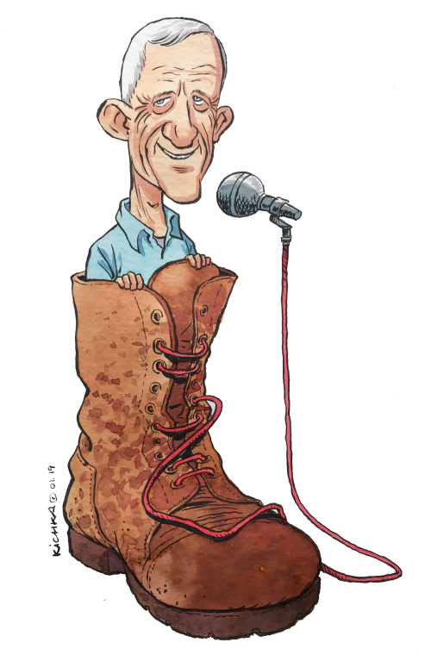
Benny Gantz going to the public with his new party “Hosen LeIsrael” and right away being marked as left to reduce the threat.
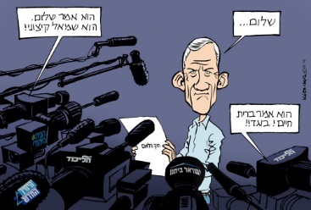

“Shalom”
“He said peace he is a radical left”
“He said life alliance, he is a traitor!”
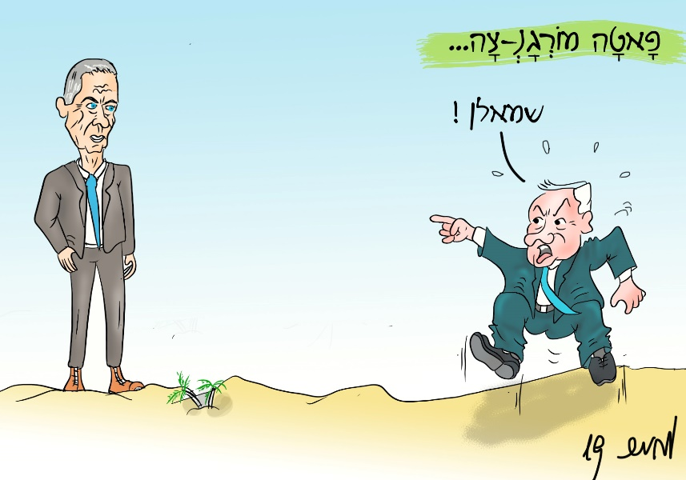
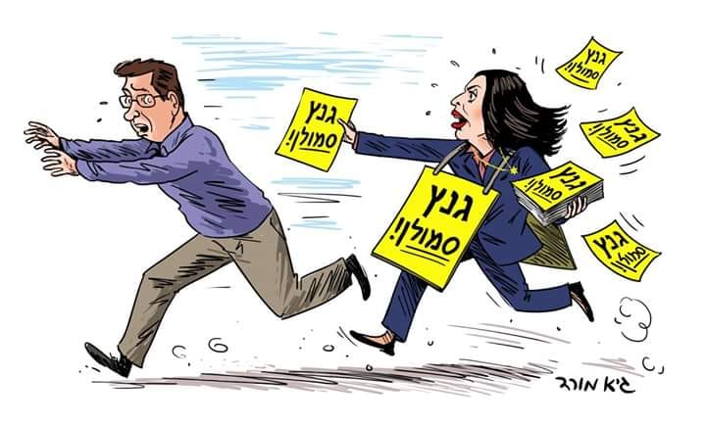
Fata Morgana-tz “lefty!”

“Gantz is a lefty!”

BIBI: “I wil never seat in a coalition with this lefty”
LIBERMAN: “I’m this lefty”

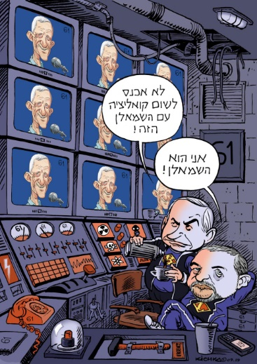

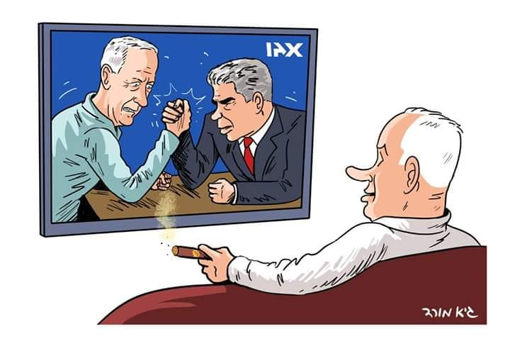

Lapid and Gantz are running in one list and having some ego fight who is the head of the party. Rotation is the decision.

Labor party is splitting from Kadima.
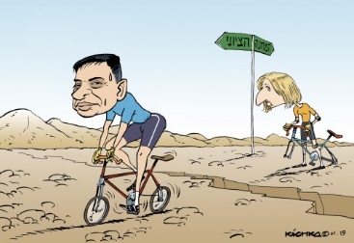

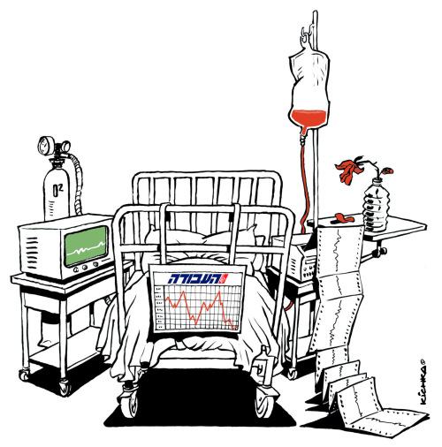
Labor party scratching the threshold.

Bibi is trying to form a coalition and stirring the pot.
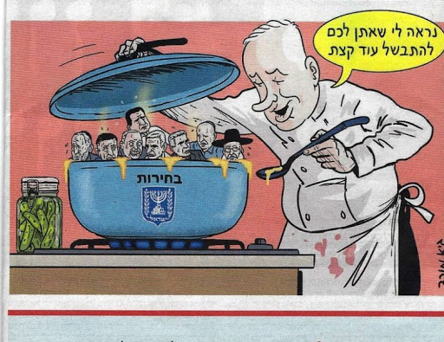

Bibi did not form a government

BIBI: wait for the next season
GANTZ: after the hearing there will be no next season

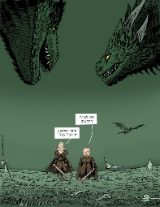
Labor party going to primaries after a bad loss.
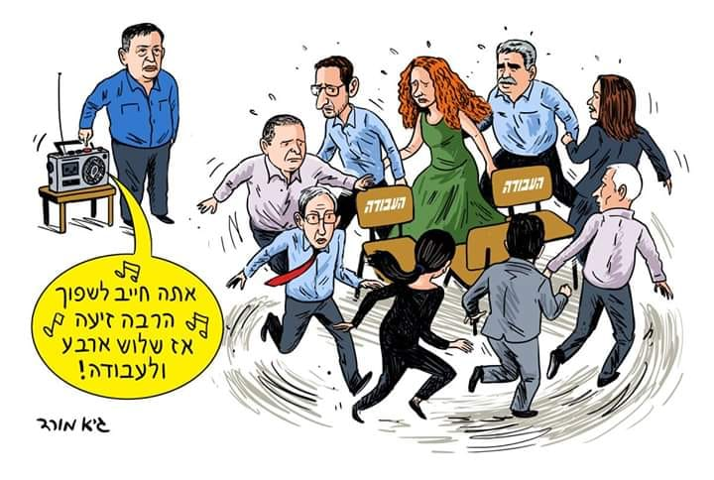

The united right wing parties choosing Shaked to be the head of their party
PEREZ: you don’t care she is not religious?
SMUTRICH: no, as long she is a national right winger.
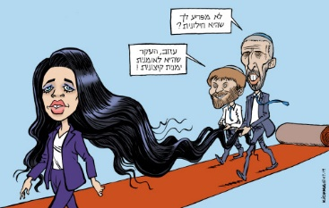

Rafi Perez nominate to be Israel’s Education Minister
“I will educate your kids in a natural healthy way”

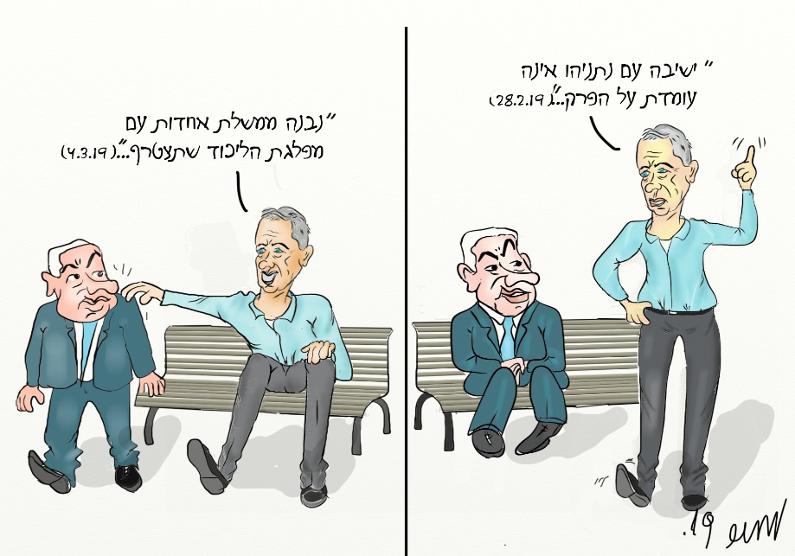
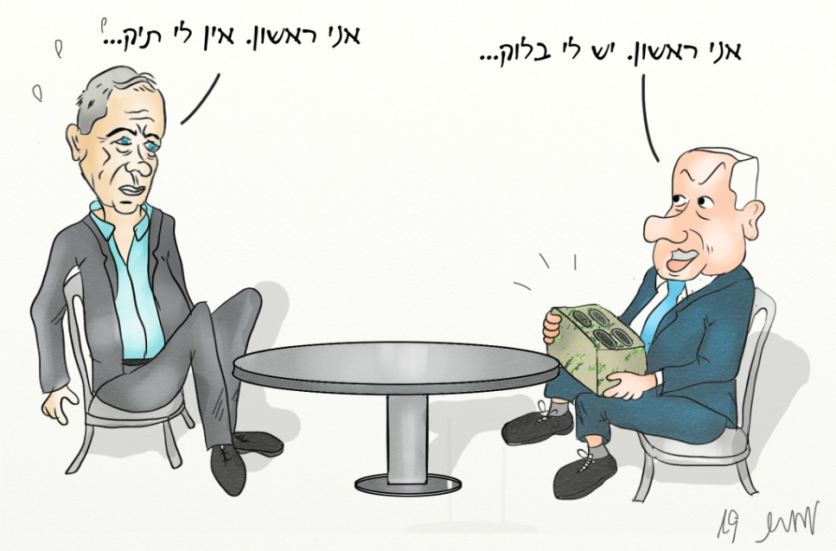
I will go first I have no charges.
I will go first I got the block.

GANTZ:
“I will never join coalition with Bibi”
ALSO GANTZ:
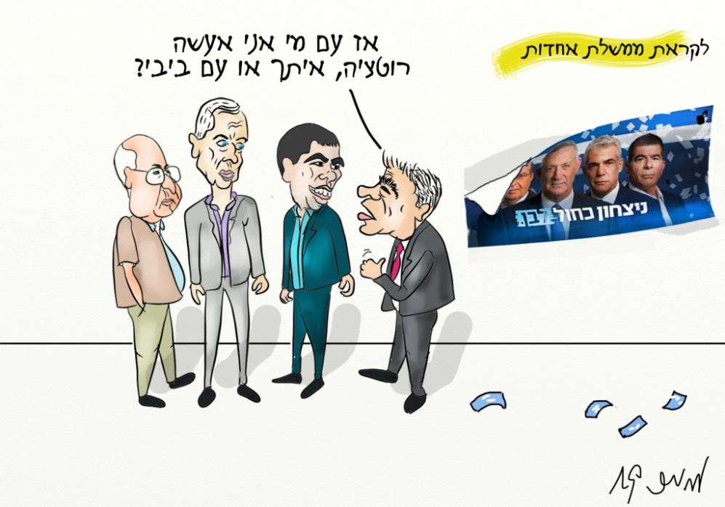
“We will build a united government with the Likud”

Lapid:
“So I rotate with you or with Bibi?”
Lieberman is not taking sides and pushing us for the next round of elections.
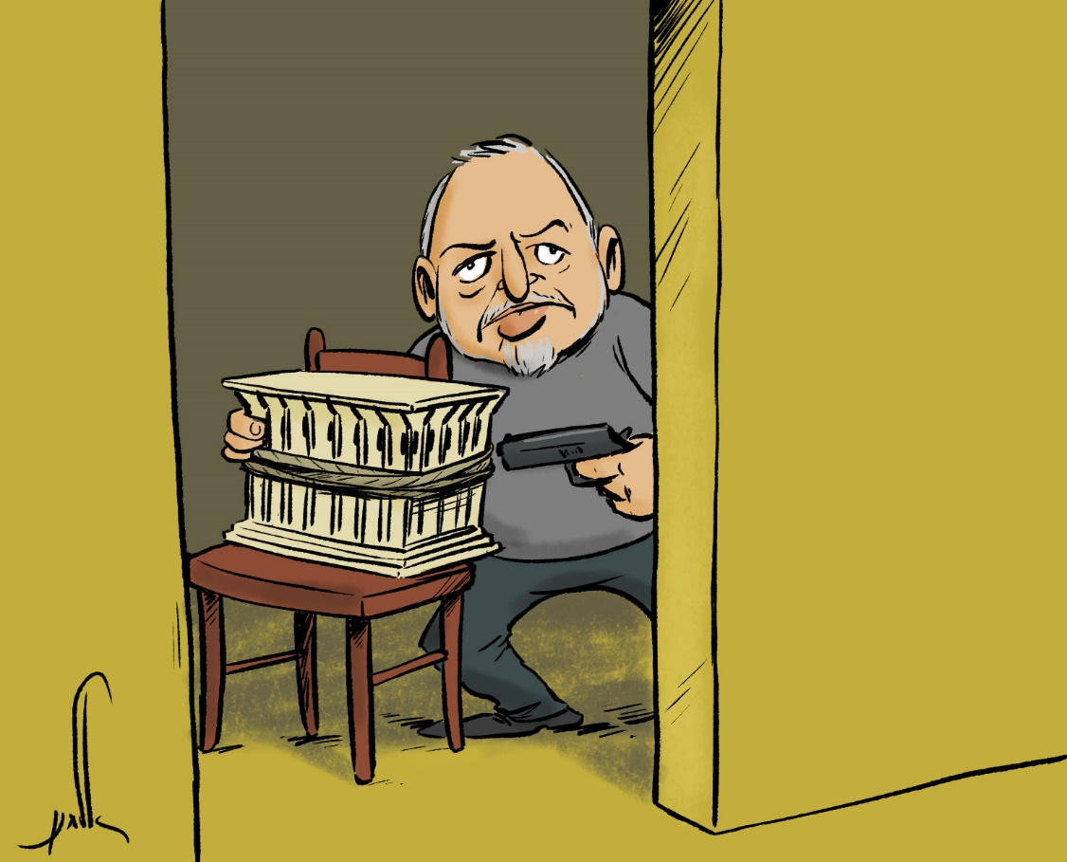

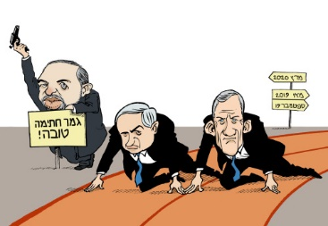
The race starts again

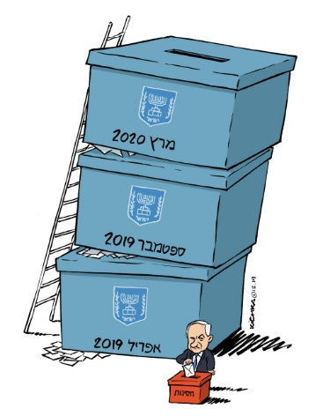

BIBI:
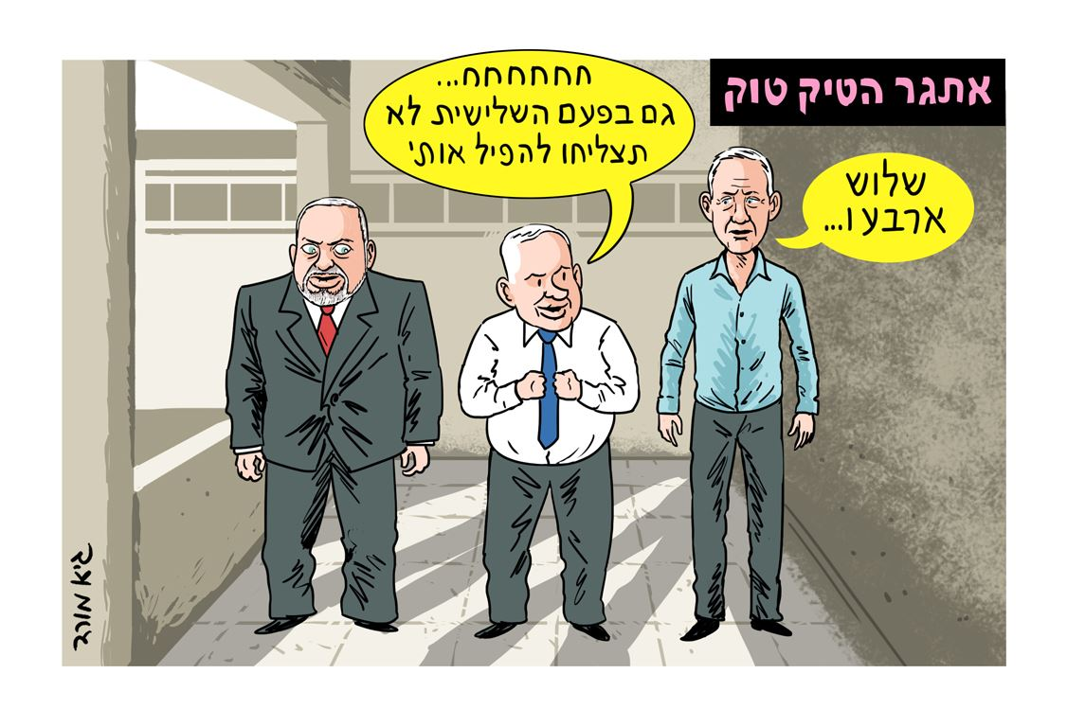
“You won’t take me down also in the third time”
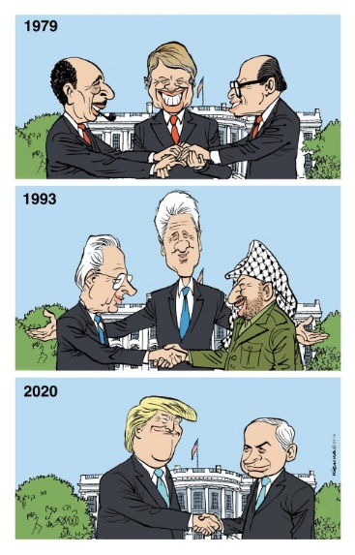
The left parties unite again, and still have small amount of mandats.
“Careful! you want to kill us?”
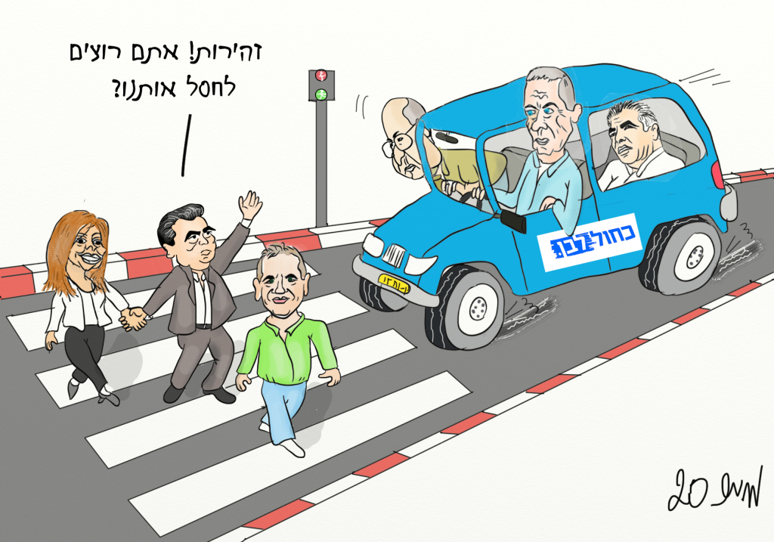

Meanwhile in Gaza:
In the shelters hearing about the Corona Virus.
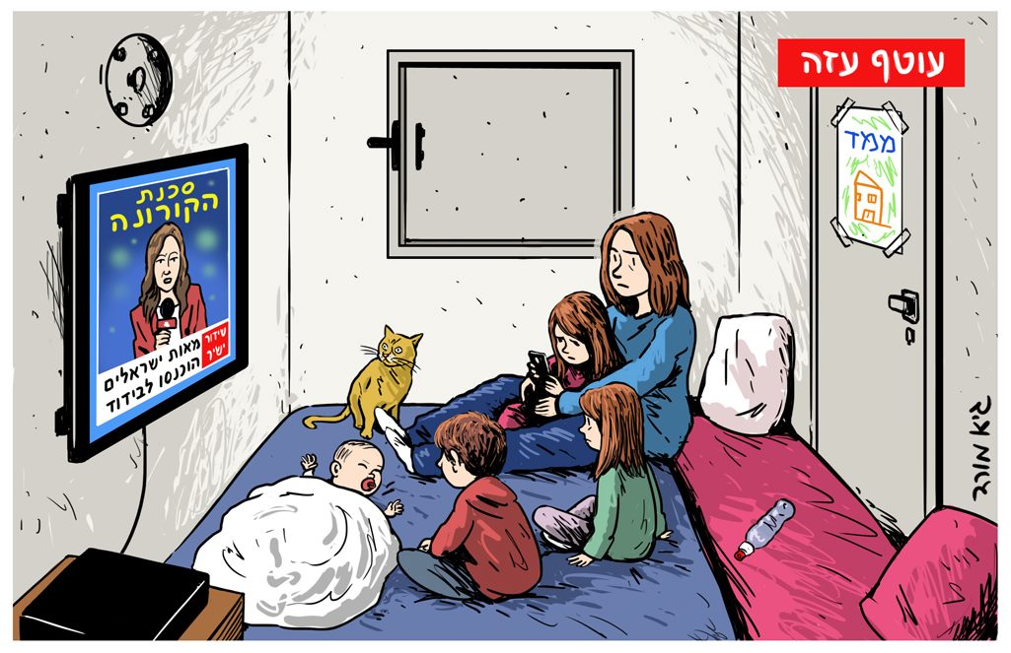
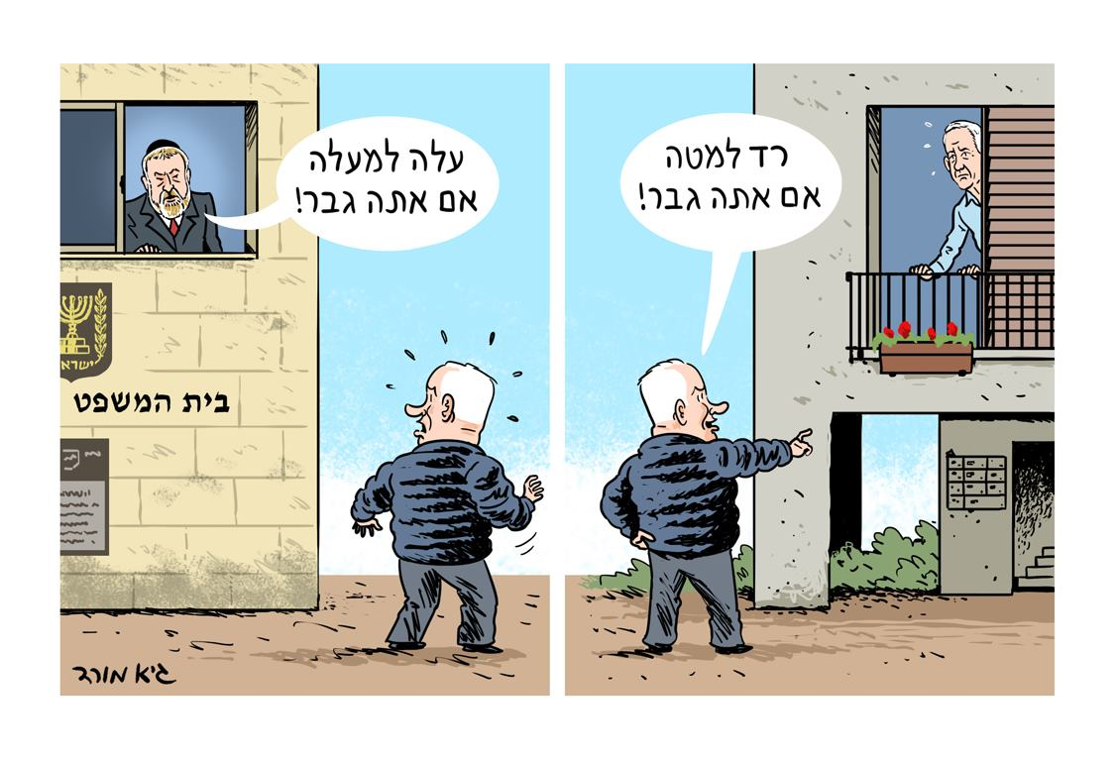

Israel’s Democracy.
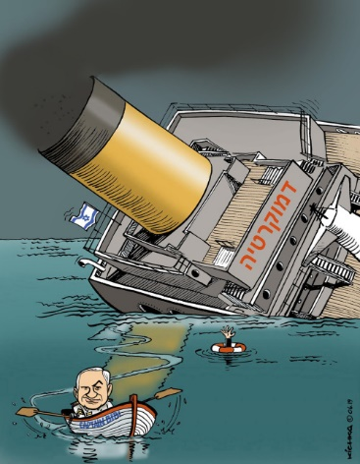
THE END (?)

