Kadesh – The First Cup 4
Urchatz – Washing of the Hands 4
Karpas – Dipping of the Greens 4
Yachatz – Breaking of the Matzah 5
Magid 6
The Second cup is now filled 6
Ma Nishtana 6
Story of Pesach 6
The Four Questions 7
Biblical Section - ??? Ten Plagues 7
Dayenu 7
Seder Plate 8
The Second Cup 9
Rachatzah – Second hand washing 9
Motzi – Blessing the Matzah 9
Matzah – Eating the Matzah 10
Maror – Tasting the Bitter Herbs 11
Korech – The Hillel S’more 11
Shulchan Orech – The Festive Meal 11
Tzafun – Finding the Afikoman 11
Birkat 11
Hallel 12
Nirtzah 12

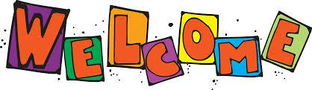

We gather here to link the past and the future and to observe the Passover with our chocolate Seder as a long time ago it was written:
Exodus 12:17 - “You shall keep the Feast of Unleavened Bread, for on this very day, I brought your hosts out of Egypt. You shall observe this day throughout the generations as a practice for all times”

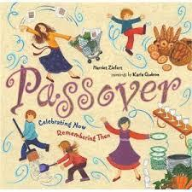

Kadesh – The First Cup
We are about to drink the first cups of chocolate milk. But why four cups? In the covenant with the people of Israel, God makes four promises. The first is Ve-ho-tzei-ti: “I will bring you out from under the burdens of Egypt.”
Remember, milk does the body good, giving us strong bones and a healthy smile. Let us thank the cows for their many hours of patient giving. Let us not forget the cocoa trees that grow and give us the sweetness of this chocolate. And let our minds turn to those who on this day are not blessed with the taste of chocolate. Together, we raise our first cup of chocolate milk and say:
Baruch atah Adonai, Eloheinu melech ha-olam, borei p’ree ha-gafen u’vorei hashoko (chalav ha-shokolad.)
ברוך אתה אדוני אלוהינו מלך העולם בורא פרי הגפן ובורא השוקו( חלב השוקולד)
Blessed are you, Adonai our God, Ruler of the universe, Creator of the Fruit of the Vine and Creator of the Chocolate Milk.
(Drink the first glass of chocolate milk.)
Baruch atah Adonai, Eloheinu melech ha-olam, shehecheyanu, v’kiyemanu, v’higiyanu lazman hazeh.
ברוך אתה אדוני אלוהינו מלך העולם שהחיינו וקיימנו והגיענו לזמן הזה
Blessed are you, Adonai our God, for giving us life, for sustaining us, and for enabling us to reach this chocolate day.

Urchatz – Washing of the Hands
As we wash our hands for the first time, no blessing is said
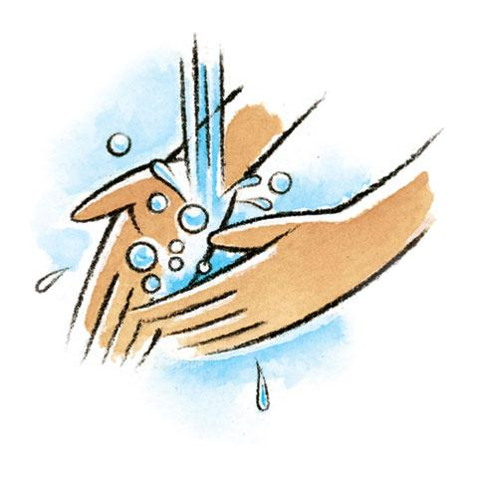

Karpas – Dipping of the Greens
We must honour the earth, which provides us with sustenance, nourishment, and chocolate fondue
Dip strawberries in chocolate and say together:)
Baruch atah Adonai, Eloheinu melech ha-olam borei p’ree ha-adamah
ברוך אתה אדוני אלוהינו מלך העולם בורא פרי האדמה
Blessed are you, Adonai our God, Ruler of the universe, Creator of the Fruits of the Earth.
(Eat the dipped strawberry.)

Yachatz – Breaking of the Matzah
- We have three chocolate matzot before us.
- Now we break the middle matzah and conceal one half as the afikoman.
- Later we will share it, as in days of old when the Passover offering was shared at this service in Jerusalem.

- Among people everywhere, sharing this bread forms a bond of fellowship. For the sake of our redemption, we say together ancient words that join us with our own people and with all who are in need.
- For all those who are unable to taste the chocolate this evening, we say together:
This is the bread of affliction, the poor bread, which our ancestors ate in the land of Egypt.
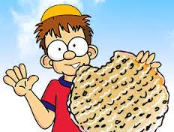
Let all who are hungry come and eat. Let all who are in want of chocolate share the hope of Passover.

Magid

The Second cup is now filled

Ma Nishtana

What has changed, this night, from all other nights?

That in all other nights we eat both chametz and matzah
on this night, we eat only matzah?

That in all other nights we eat many vegetables, on this night, maror?

That in all other nights we do not dip vegetables even once, on this night, we dip twice?

That in all other nights some eat sitting and others reclining, on this night, we are all reclining?

Mah nishtanah, ha-laylah ha-zeh, mi-kol ha-leylot?

She-b'khol ha-leylot 'anu 'okhlin chameytz u-matzah, ha-laylah ha-zeh, kulo matzah?

She-b'khol ha-leylot 'anu 'okhlin sh'ar y'raqot, ha-laylah ha-zeh, maror?

She-b'khol ha-leylot 'eyn 'anu matbilin 'afilu pa`am 'achat, ha-laylah ha-zeh, shtey fe`amim?

She-b'khol ha-leylot 'anu 'okhlin beyn yoshvin u-veyn m'subin, ha-laylah ha-zeh, kulanu m'subin?

Story of Pesach
After many decades of slavery to the Egyptian pharaohs, during which time the Israelites were subjected to backbreaking labor and unbearable horrors, G‑d saw the people’s distress and sent Moses to Pharaoh with a message: “Send forth My people, so that they may serve Me.” But despite numerous warnings, Pharaoh refused to heed G‑d’s command. G‑d then sent upon Egypt ten devastating plagues, afflicting them and destroying everything from their livestock to their crops.
At the stroke of midnight of 15 Nissan in the year 2448 from creation (1313 BCE), G‑d visited the last of the ten plagues on the Egyptians, killing all their firstborn. While doing so, G‑d spared the Children of Israel, “passing over” their homes—hence the name of the holiday. Pharaoh’s resistance was broken, and he virtually chased his former slaves out of the land. The Israelites left in such a hurry, in fact, that the bread they baked as provisions for the way did not have time to rise. Six hundred thousand adult males, plus many more women and children, left Egypt on that day, and began the trek to Mount Sinai and their birth as G‑d’s chosen people.

The Four Questions
The four questions reflect the curious paradox of servitude and redemption. The matzah, which is the subject of the first question, is slaves bread but also a symbol of freedom. We go on to bitter herbs in the second question. They are a symbol of servitude, but their use of hors d’oeuvres and their being dipped into another food is a sign of opulence.

Similarly, the third and fourth questions; We eat karpas dipped in salt water, which is reminiscent of Jewish pain and tears, yet we recline as a show of redemption. In essence, the four questions touch upon the paradox of seder night, when the symbols of servitude and suffering intertwine with those of redemption.

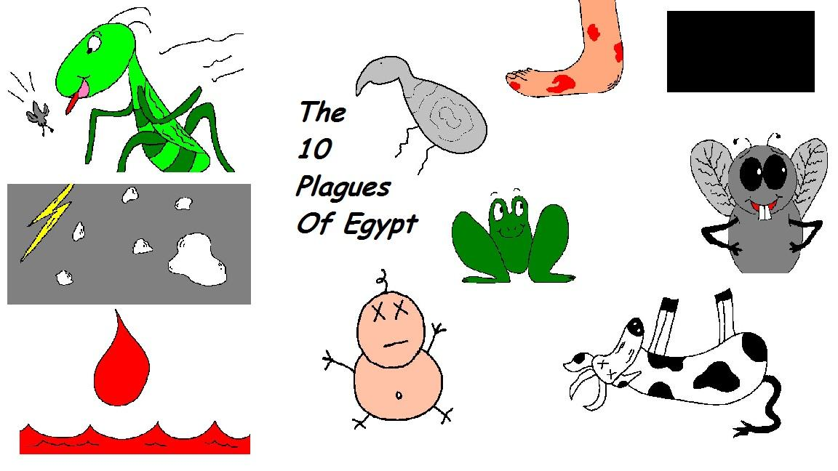
Ten Plagues
- Blood
- Frogs
- Lice
- Insects
- Cattle Disease
- Boils
- Hail
- Locusts
- Darkness
- Slaying of the first born

Dayenu
If He had brought us out from Egypt,
Ilu hotzianu mimitzrayim,
אִלּוּ הוֹצִיאָנוּ מִמִּצְרָיִם
and had not carried out judgments against them
v'lo asah bahem sh'fatim,
וְלֹא עָשָׂה בָּהֶם שְׁפָטִים
— Dayenu, it would have been enough!
dayeinu!
דַּיֵּנוּ
If He had carried out judgments against them,
Ilu asah bahem sh'fatim
אִלּוּ עָשָׂה בָּהֶם שְׁפָטִים
and not against their idols
v'lo asah beloheihem,
וְלֹא עָשָׂה בֵּאלֹהֵיהֶם
— Dayenu, it would have been enough!
dayeinu!
דַּיֵּנוּ
If He had destroyed their idols,
Ilu asah beloheihem,
אִלּוּ עָשָׂה בֵּאלֹהֵיהֶם
and had not smitten their first-born
v'lo harag et b'choreihem,
וְלֹא הָרַג אֶת בְּכוֹרֵיהֶם
— Dayenu, it would have been enough!
dayeinu!
דַּיֵּנוּ

Seder Plate
In front of us sits the Chocolate Seder Plate. Upon it are six chocolate symbols that capture the essence of the story of Passover – in a melt-in-your-mouth sort of way.

Z'roa – Chocolate Drumstick זרוע
Representing the sacrificial lamb of Passover. The blood of the lamb was placed on the doorposts of Jewish homes, so that God would "pass over" those homes, sparing the children of the Jews from the tenth plague – the killing of the first-born son.

Beytzah - Chocolate Egg ביצה
First of all, the egg represents the Festival Sacrifice brought to the Temple years ago at this season. Secondly, the roundness of the egg represents the continuous cycle of nature’s seasons.

Maror - Bitter Chocolate מרור
This bitter chocolate represents the bitterness of our ancestors' enslavement in Egypt. It helps us to remember that although our ancestors were delivered from Egypt, we are all still enslaved in our own personal Egypt.

Karpas – Strawberry כרפס
Like the sumptuous chocolate egg, the strawberry symbolizes the rebirth of the world at this spring season.

Charoset - Chocolate Mixture חרוסת
A representation of the mortar that our ancestors used as slaves in Egypt.

Orange - תפוז
In the days long ago when women were just beginning to be rabbis, Susannah Heschel was travelling in Florida, the Land of Oranges. One night she spoke at a synagogue about the emerging equality of women in Jewish life – as rabbis, teachers and students of Torah, synagogue presidents, and in all other ways.
After she spoke, a man arose in wrath, red with fury, and said, "A woman belongs on the bimah as much as an orange belongs on the Seder plate!"
So ever since that day, we place an orange on the Seder plate, for it belongs there as a symbol that women belong wherever Jews carry on a sacred life.

The Second Cup
The cup of chocolate milk that was poured as we began the Magid is now to be drunk as we conclude the telling of the story. This cup was witnessed the tale of God’s deliverance of the Jews from Egypt – Ve-hi-tzal-ti: “I will deliver you from their service”. It offers hope that we may be delivered from all the afflications in this world, and that we may never be without chocolate again.
Together, we raise our second glass of chocolate milk and say:

Baruch atah Adonai, Eloheinu melech ha-olam, borei p’ree ha-gafen u’vorei ha shoko

ברוך אתה אדוני אלוהינו מלך העולם בורא פרי הגפן ובורא השוקו
Blessed are You, Adoinai our God, Rule of the Universe, Creator of the Fruit of the Vine and Creator of Chocolate Milk
(drink second glass of chocolate milk)

Rachatzah – Second hand washing
The priests in the Temple would wash their hands before approaching the altar. Similarily, we wash our hands at this stage to approach the table with clean hands and a pure heart. So that we may sanctify the act of eating.
(Then we remain silent until the blessing for the matzah is said)
Baruch atah Adonai, Eloheinu melech ha-olam, asher kidishanu b’mitzvotav v’tzivanu al netilat yadayim
ברוך אתה אדוני אלוהינו מלך העולם אשר קדשנו ומצוותניו וצוונו על נטילת ידיים
Blessed are you, Adonai our God, Ruler of the Universe, who sanctified us with mitzvot and commanded us to wash our hands.

Motzi – Blessing the Matzah
Blessed is God, who created a world where we can bring forth the components of bread and chocolate, our sustenance, from the earth
(the upper matzah is broken and distribute, and all say)

Baruch atah Adonai, Eloheinu melech ha-olam, ha-motzi lechem u-shokolad min ha-aretz.
ברוך אתה אדוני אלוהינו מלך העולם המוציא לחם ושוקולד מן הארץ
Blessed are you, Adonai our God, Ruler of the universe, Who brings forth bread and chocolate from the earth.

Matzah – Eating the Matzah
Baruch atah Adonai, Eloheinu melech ha-olam, asher kidishanu b’mitzvotav v’tzivanu al achilat matzah.
ברוך אתה אדוני אלוהינו מלך העולם אשר קדשנו במצוותיו וצוונו על אכילת מצא
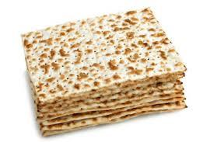
Blessed are you, Adonai our God, Ruler of the Universe, Who sanctified us with mitzvot and commanded us to eat matzah.

Maror – Tasting the Bitter Herbs
God, we recognize your commandments and they ways in which we feel holy when we observe these commandments, especially one as difficult as eating this bittersweet chocolate

Baruch atah Adonai, Eloheinu melech ha-olam, asher kidishanu b’mitzvotav v’tzivanu al achilat maror.
ברוך אתה אדוני אלוהינו מלך העולם אשר קדשנו במצוותיו וצוונו על אכילת מרור
Blessed are you, Adonai our God, Ruler of the Universe, who sanctifies us with mitzvot and commands us to eat bitter herbs and bittersweet chocolate.
(Dip some bittersweet chocolate into the chocolate mix and eat them together.)

Korech – The Hillel S’more
This is what Hillel the Elder used to do in the time that the Holy Temple still stood. He would mix the Pesach offering with matzah and maror and eat them together, so as to properly carry out the Torah's injunction: "On matzah and bitters they shall eat it" (Numbers 9:11).
(Combine matzah, chocolate mix, and bittersweet chocolate and eat them)

Shulchan Orech – The Festive Meal

Let My People Eat!

Tzafun – Finding the Afikoman
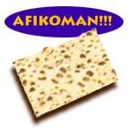

Birkat
- The cup is fill for a third time
- Birkat Hamazon
And we bless:
Blessed are You, Lord our God, King of the Universe, who creates the fruit of the vine.
Baruch Atah Ado-nai Elo-heinu Melech Ha-olam Boreh Pree Ha-ga-fen.

Welcoming Elijah
The fourth and final cup of wine is now filled. An additional cup is then filled and set aside for the prophet Elijah (Eliyahu). Tradition says that Elijah, who will precede the arrival of the Messiah, makes an appearance at every Seder. We traditionally open a door to the home to allow Elijah to enter and sing the song Eliyahu Hanavi:
Elijah the Prophet, Elijah the Tishbite, Elijah the Giladite, may he come speedi- ly to us in our days along with Messiah the son of David.
Eliyahu Hanavi, Eliyahu Hatishbi, Eliyahu Hagiladi, Bimheirah Yavo Eileinu Im Mashiach Ben David

Hallel

the blessing over the fourth cup of wine is recited:
Baruch Atah Ado-nai Elo-heinu Melech Ha-olam Boreh Pree Ha-ga-fen
Blessed are You, Lord our God, King of the Universe, who creates the fruit of the vine.

Nirtzah
We conclude the official part of the Seder with a final prayer asking God to bring the Messianic Era, when all of us will be gathered to Jerusalem as all humankind dwells in peace.
We have finished the Passover Seder according to its precepts and customs. Next Year in Jerusalem!!
Lishana Ha-baah Bi-yerushalyim
Next year, may we all dwell in peace!

