**Mimuna Celebration @ Olam Tikvah**

1. **Date**: Sunday, April 8th, 12:00pm-14:00pm.
2. **Cost per person**: 5$ per adult. First child’s admission is included with the purchase of an adult ticket, $3 per additional child.
3. **Location**: Congregation Olam Tikvah, 3800 Glenbrook Rd, Fairfax, VA 22031.
4. **Blurb**: Come and discover a new culture, full of tastes, rituals and history.  
   The Mimuna is a North African Jewish celebration that is celebrated in the end of Passover and symbolizes the need in luck and success. We will make and eat Moroccan delights, do henna tattoos, watch a magnificent belly dancing show and meet Noy’s mom that comes especially from Israel for this event. Celebrate the end of Pesach with!  
   And as the old Moroccan saying “תרבחו ותסעדו”. Come. Feel comfortable. Eat. Be Happy.
5. **Budget**:

|  |  |  |
| --- | --- | --- |
| Food | All the food is being made by hand. The budget is according to the recipes we will use. | 500$ |
| Renting electric stove | Buying to make Mufletta in the Social Hall. | 100$ |
| Graphic designer | Includes fliers, digital designs for Facebook and other platforms. | - |
| Prints | For posters, signs etc. | 62$ |
| Plates, Utensils and tablecloth | Special plates, utensils and tablecloths in gold and silver (bought from Party City). | 126$ |
| Mashgiach | As we will be in the kitchen we will need a mashgiach. | 150$ |
| Traditional costumes | Includes jewelry in gold and silver for the hosts as well as for community use. Traditional clothes straight from Israel (few will be the prize in a raffle). | 170$ |
| Belly dancing | Learning about the North African tradition as watching a performance and dancing with belly dancer. | 250$ |
| Henna | Doing Henna as many Mizrahi traditions do | 250$ |
| **Total** | | **1,608$** |

1. **Other details**: Lots of decorations in the social hall. In the middle - a long table with white/decorated table cloth filled with gold/silver plates filled with delicacies (on the tablecloth we will write תרבחו ותסעדו). In the background there will be speakers that play Mimuna/Moroccan music. We will have a photobooth, Henna artist and decoration making for the little kids. While everyone will eat, Noy will go on stage and explain a little more about the culture she is coming from. Her mom will go right after her in explaining a bit more about wanting to be a part of the Moroccan tradition as getting married to one.

Added some pictures:

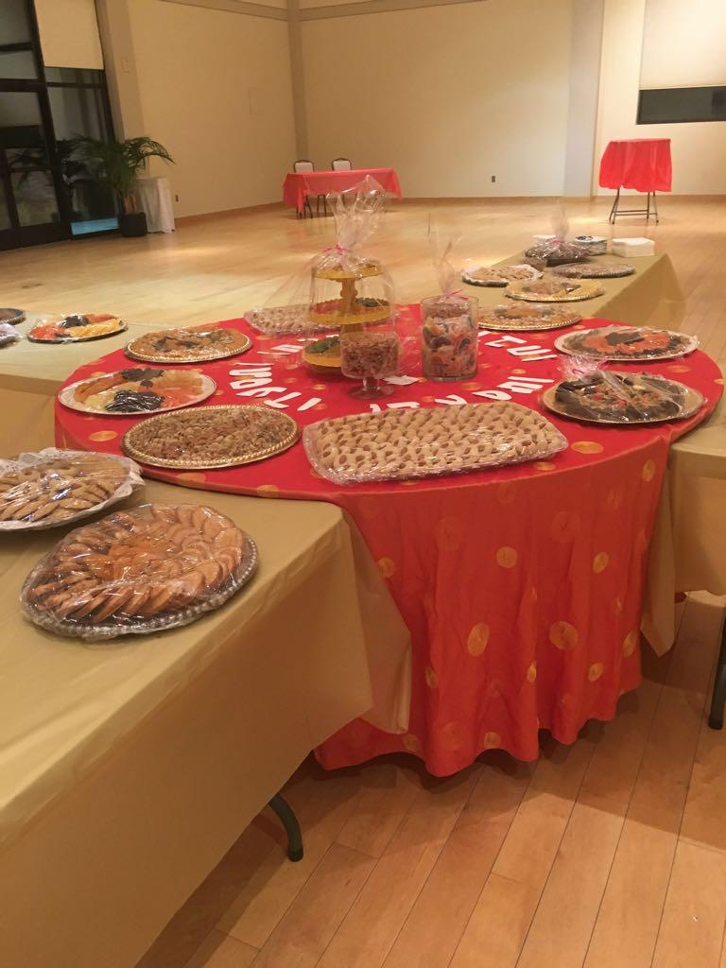

**מה מכינים?**

עוגיות קוקוס

עוגיות טחינה  
נשיקות מרנג  
עוגיות מרציפן  
פירות יבשים  
תמרים ממולאים באגוזים  
מופלטה (עם חמאה ודבש)  
סוגי ריבות שונות  
ז'בן

**מה קנינו בקוסטקו?**

סוכר גדול  
לימון

חלבונים

ג'לטין

אגוזים

שקדים

1 קג קמח

שמרים

1 כף מלח

1 כף סוכר

שמן קנולה לטיגון - גדול

חמאה מומסת (גדולה)

ביצים - L - חבילה גדולה

אבקת אפייה

תמצית וניל

קוקוס טחון - 3 חבילות

אבקת סוכר - חבילה אחת

שוקולד שחר לילדים